Intent: We believe that all children can deepen their understanding within mathematics across our school through motivated teachers, courage and perseverance. At Bromesberrow St Mary’s Primary School, we are continuously developing the mindsets of both children and staff, building resilience and a ‘can do’ attitude to be well rounded, motivated and successful mathematicians. With high quality first teaching and expectations, intelligent practice, collaborative learning and intervention and support, all our children will be given every opportunity to develop their declarative and procedural knowledge within maths and explore mathematics deeply (conditional knowledge), being positively enabled to Shine Together, We Reach for the Stars in our learning of mathematics.
Mastery approach at Bromesberrow St. Mary’s C of E Primary School in Mathematics.

Our definition of Mastery: At Bromesberrow St Mary’s Primary school we believe that all children are capable of doing and understanding mathematics with the right teaching and support. Through building a ‘can do’ attitude, with high-quality teaching, resources and effort; all children can enjoy and achieve within maths through carefully planned small steps. Throughout our school, we are driven to provide children with the key concepts and building blocks to be brilliant and aspirational mathematicians.

Following the five Big Ideas, our lessons are designed to support the teaching of Mastery.
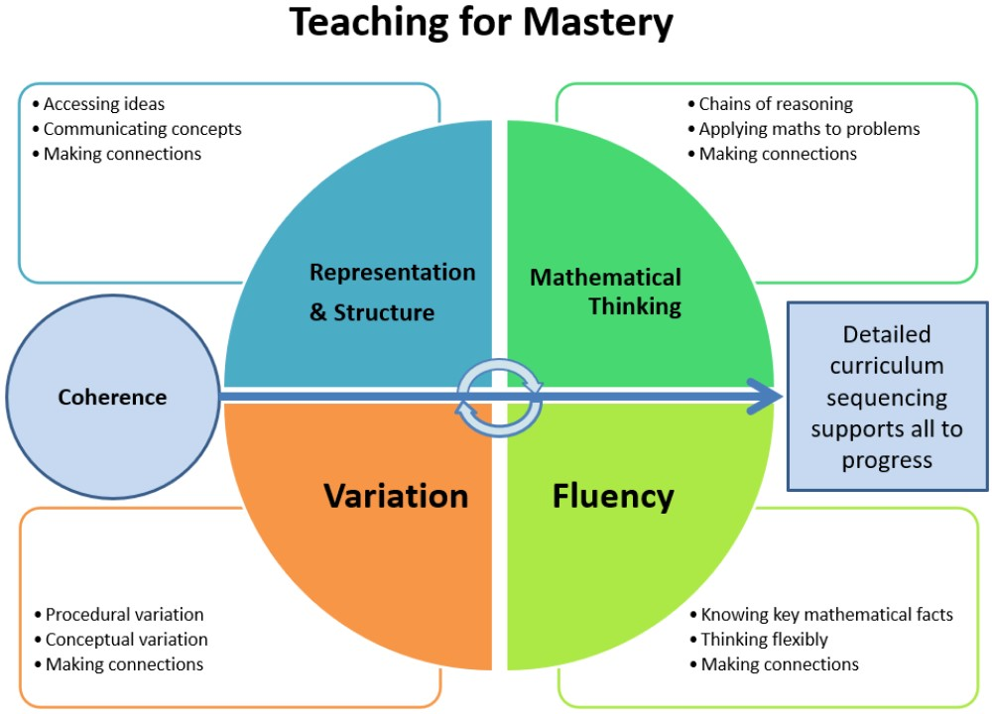

Implementation:
Mastery is the ‘knowing’ and ‘understanding’ of key concepts combined; it is not just about being able to answer questions quickly and accurately. Mastery is knowing why and how and being able to select the most appropriate methods for them. All our children are provided with these examples during their teacher input whilst following a sequence of concrete, pictorial and abstract teaching and questioning, with learning appropriate to the learning need within the classroom and to enhance their fluency, reasoning and problem solving learning, which are central strands to the teaching of mathematics. We aim to see our children being able to use their knowledge appropriately, flexibly and creatively; applying their knowledge to new and unfamiliar situations.

For all mathematical concepts, children are provided with the opportunities to be “challenged through being offered rich and sophisticated problems.” After the children have developed fluency (Skill it), they need to be able to show that they can apply their knowledge in the form of reasoning (Apply it) in mathematics and be able to move further to demonstrate they have mastered (Deepen it – problem solving) the concepts in a range of different ways.

As a school we follow these definitions of fluency, reasoning and problem solving to support our mastery approach.

Fluency: the development of number sense (facts, formulas, concepts and rules) and being able to use the most appropriate method with increasing efficiency – procedural knowledge/declarative knowledge. (Skill it)
Reasoning: the process of applying logical and critical thinking to a mathematical problem in order to work out the correct or incorrect strategy to use in reaching a solution and being able to explain how they came to the answer they did. An important area that provides the foundations of problem-solving – declarative knowledge/conceptual knowledge (links between mathematical knowledge). (Apply it)
Problem Solving: is deepening understanding through answering unfamiliar problems/questions and having the skills and knowledge to do so through problem solving strategies and being exposed to a range of problem types – conditional knowledge. (Deepen it)

Problem solving strategies include: working systematically, conjecturing (a conclusion that may be true from using some reasoning but yet to be proven), visualising, working backwards, pattern spotting and trial and improvement.

Types of problems: visual problems, word problems, finding all possibilities, logic problems and rules and patterns.

Our Mathematics in Mastery curriculum (see Maths Overview): From our Early Years to Year 6, our curriculum allows learners and teachers to be successful in Maths by achieving a secure and deep understanding of a Mathematical concept. We have designed our Mastery Curriculum to provide teachers with the opportunity to address key points individually with clear vocabulary expectations, ensuring that the children have a secure understanding of those points before offering the opportunity to ‘go deeper’ within them. In Early Years and where appropriate in Year 1, the principles of EYFS will be followed, and there will be an opportunity to ‘Explore Maths’ and develop their understanding of Mathematical concepts through play and a range of scenarios throughout their continuous and enhanced provision. Allowing the children to be critical thinkers and actively involved in their learning. The curriculum has been designed in line with the National curriculum and Early Years Statutory Framework as progressive learning whilst our children learn and grown with us to continuously be building upon their already obtained knowledge from previous learning.

Fluency Progression document: Clearly outlines the progression of children’s fluency knowledge to support teacher’s to teach fluency in a coherent and well thought out way.

Mastery teaching and learning: In every Mathematics lesson across the whole school, you will see the following:
- Quality First Teaching; tailored to meet the needs of the learners in each class, and intervention being given to address any gaps in learning when necessary to,
- Resilient and motivated learners, with a learning environment that promotes a ‘can do’ attitude using 3B4ME,
- Teachers and Teaching Partners using high-quality questioning to explore children’s understanding and develop understanding further,
- Teachers using misconceptions to further understanding of key concepts,
- Learners being provided with a range of opportunities to explore key mathematical concepts that appeal to the children's different learning styles – concrete/pictorial/abstract,
- Collaborative learning,
- Learners being provided with the opportunities, through careful planning, to explore for longer and go deeper in mathematical concepts,
- Development of fluency, reasoning and problem-solving.
- Teachers and Teaching Partners explicitly modelling new learning through an episodic teaching approach.
Peer Mentors
We encourage our children to be peer mentors within the classroom, which shows a deeper understanding of the concept they are learning as they will need to be able to adapt and explain/reason to support their peers. This not only shows our children Reaching for the stars in themselves, but supporting others to do the same to Shine Together.
Disadvantaged and SEND backgrounds
Our mastery approach has been designed carefully to support all children in being able to develop a rich understanding of Maths including children with SEND and disadvantaged backgrounds. With opportunities to consolidate and revisit throughout our curriculum we believe we provide an ambitious curriculum that is accessible to all. Our carefully planned curriculum is not built to support children to ‘catch up’, but to allow children the heightened opportunity to ‘keep up’.
Our teaching staff are able to use adaptive teaching and their judgement to ensure that those children who need it are being provided with the curriculum in a way that is accessible to them – enabling all our children to Shine Together and Reach for the Stars. Key resources such a number stacks and numicon are used to support learning through intervention but also as tools to use in the classroom.

Adaptive teaching within Mathematics:
Breaking lessons up into smaller chunks, rephrasing information so that it is accessible for all, allow time for questioning, tailoring resources (Maths toolboxes, visual aids, help sheets), pre-teach the lessons skills that will be taught that day, pre –teach prior vocabulary, peer support or targeted support from the teaching/ teaching partner, adults knowing how to use other manipulatives to support learning if the suggested resource does not suit learning need, time to practice using resources during input, show examples of finished pieces for something to work towards, episodic approach to learning (my turn, your turn) to support attention, provide word/ picture banks for learners to refer to, use of modelling to support a step by step process, display key vocabulary for children to use, practice saying them altogether, ensure vocabulary becomes embedded by referring to it regularly during lessons whilst modelling, encourage time to talk, think and share ideas, small group learning, clear examples on the working wall to use as an aid memoire and during word problems, have an image to refer to.
Fluency practise:

At Bromesberrow, teachers incorporate Fluency practise 4 times a week into their timetables outside of their maths lessons to consolidate previous years Maths objectives (throughout the Autumn Term) and revisiting current year’s objectives once taught. This allows assessment to take place for teachers, focused intervention time and children to further secure their understanding and fluency of prior learning objectives. These sessions support the children in feeling ‘more ready’ to embark on new learning within a mathematical concept. Teaching staff plan for these in ways that are appropriate for the children they are teaching within their class e.g. fluent in 5, practical exploration of maths, Mastering Number (KS1 and Reception).

Fluency Session Timetable suggestion:

Monday | Place value
Tuesday | Four operations (timestables)
Wednesday | Fractions/ Decimals/ Percentages
Thursday | Shape and measure
Friday | Consolidation when needed

Mastering Number

For our Reception children, this programme from NCETM helps teachers to ensure ALL children are able to develop fluency and flexibility with number that we can describe as ‘good number sense’. This mean children who are able to Subitise, understand how numbers are composed and can be decomposed, compare quantities and see how numbers are related. Having a deep and secure foundation of number lays the firm foundations that sets children up for success later on. Further allowing all children, including those from disadvantages backgrounds to have greater experiences to hear and talk about number in their everyday lives that they may not be getting elsewhere.

Non-negotiables:

- Skill it, Apply it and Deepen it language to be used in Maths to show fluency, reasoning and deepened problem solving. All staff to be confident and conversant in this terminology.
- Terminology and language to be used and understood by children.
- All children to be exposed to Skill it, Apply it and Deepen it style questions during teacher input.
- All worksheets to be printed in blue.
- Fluent in 5 rule followed (no more than 5 fluency questions given, unless understanding not secure).
- Fluency sessions 4 times a week revisiting previously learnt knowledge to improve fluency (Addition, Subtraction, multiplication, division, fractions, decimals, percentage, place value, shape and measure, times tables) where appropriate to age group.
- KS2 (Year 4 – 6) to draw a margin in their books for question numbers and/or quick workings out.
- Year 3 – Year 6 children to write short date into their books.
- Year 4 – Year 6 children to write Roman numeral date alongside numerical date.
- All work to have a clear Learning objective.
- Maths toolboxes to be out for children every Maths lesson and incorporated into resilience 3B4Me poster shown in classroom.
- Adults model use of manipulatives linked to that learning objective.
- Maths working wall to clearly show current learning objective.

Manipulatives:

Within each class:
Class 1 equipment available to the children: number line to 50, 100 square, counters to pv of 10, numicon, scales, objects for counting,
Yr 2: base ten tens ones, place value counters tens ones, coins and notes sterling, hundred square, number lines to 100, pv charts tens ones, money pv charts £ 10p 1p, straws/lolly sticks, pv frames, pv arrows (mainly teacher use) numicon, 10 frames and counters.

Class 2 equipment available to the children:

Yr 3/4: base ten thousands, hundreds, tens ones, place value counters thousands, hundreds, tens and ones, coins and notes sterling, Cuisenaire rods, hundred square, number lines to 100 and 1,000, pv charts hundreds tens ones, money £, 10p, 1p, scales, weights, place value grids.

Class 3 equipment available to the children:
Place value grids up to 1million, multiplication grids, fraction walls, place value counters up to 1 million and decimal counters, thermometers, money, scales, weights, compose, protractor.

In all classrooms children have access to: base ten, numicon, physical shapes.

For each Mathematical topic:

Place value: Two sided counters, dienes, place value counters, tens frames, part-part whole model, numicon, rekenreks, bead string, place value chart, Cuisenaire rods, 100 square, number lines

Addition, Subtraction, Multiplication and Division: nuimcon, counters, place value counters, tens frame, numicon, part-part whole model, bar model, multi link cubes, 100 square, multiplication and division square, place value arrow cards, dice, counting stick, dienes, number lines, rekenrek.

Fractions, decimals and percentages: fraction, decimal and percentage cubes, numicon, tens frames, fraction circles, fraction and decimal place value counters, fraction wall mat, Cuisenaire rods, dienes,

Converting units: place value chart

Ratio: bar model, counters

Algebra: bar model, Cuisenaire rods, multilink cubes, counters

Perimeter, area, volume: numicon, multilink cubes

Statistics: graph paper

Shape: protractors, physical shapes, geoboards

Position and direction: bee bots,

Money: physical money

Time: clocks

Mass, capacity and temperature: scales, thermometer, containers

Length and height: ruler, meter stick

Impact

The impact of our mathematic curriculum is monitored through the use of our assessment tracker, Insight. This is also partnered with book looks, lesson pop ins and pupil voice. Through the carefully designed curriculum, our children are in a position to continue to develop their mathematic understanding into their following years of education and be confident, conversant mathematicians. This curriculum design has shown an increase in positive attitudes towards math’s and children who are not afraid to ‘give maths a go’, whilst being able to grapple with a deepening level of understanding through our small step planning.

