Writing Text Overview
At Bromesberrow St. Mary’s we have put together a ‘quality text’ planner, which we base our English lessons around. You will see in our English books that we have a ‘front cover’ introducing each text, with clear outcomes and intentions, as well as the promise of a ‘final published piece’. Our children find this helpful to understand that their writing has purpose and an audience. All of our texts have been carefully chosen to ensure that there is a good spread of literature. All texts have been chosen with our children in mind. They are planned in advance, but can be changed by negotiation if something exciting or different comes to our attention!

Class One (Reception and Year One)
Cycle 1
 | English Text | Grammar, spelling and punctuation | Learning outcomes | Published Piece | Reception  Adult Directed Suggestions
Aut A (1) | Peace at Last by Jill Murphy  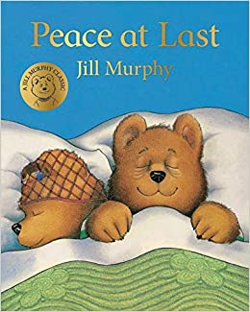 | Y1  Use different verbs e.g. the tap dribbled/gushed/spat  Children leave spaces between words when they are writing  Children are able to join words and clauses using ‘and’  *Using spelling rules and common exception words taught so far (see Phonics and Spelling Overview) | Y1  To write a retelling of the story of Peace at Last  To innovate the story to change the events. | Y1  To write a nocturnal animal fact file | - Listening to and joining in with the story e.g. making the sounds and moving to represent different events  - Retelling the story through small world and props. Vocabulary: focus on adverbs e.g. the cat meowed loudly, the fridge hummed constantly, the tap dripped annoyingly.  - Making paper aeroplanes and testing, and making a ‘boat that will float’. Adult to encourage curiosity and questioning asking ‘I wonder what will happen if?’ and ‘What might happen when?’ and ‘why do you think?’  - Making their own big aeroplane out of big construction, challenging children through pondering…hmmm…I wonder how this might work. Support and introduce Vocabulary e.g. the tiny wheel and the long, thin box.  - Light and dark- torches, light boxes and exploration. Adult to use open ended questioning think ‘why, what, how, when?’ e.g. I wonder how the torch lights up? Vocabulary: light, dark, reflect, shiny, bright, shadow, prism  - Sounds- sound walks, sound lotto, music to represent sounds.  - Teddy Bears picnic: Instruction writing e.g. how to make sandwiches or teddy biscuits. What do we need? Vocabulary: time connectives-First, Then, Next, After that, Finally and verbs- mix, stir, pour, measure, taste, wash, use and weigh.  - Nocturnal animals: Building new vocabulary to describe the animals encountered in the story. Children could create fact files or use new descriptive Vocabulary to write about their favourite animal. Vocabulary- adjectives-furry, feathery, sharp, pointed, wet, rough, tiny,
Aut A (2) | Year 1: Rosie’s Walk by Pat Hutchins  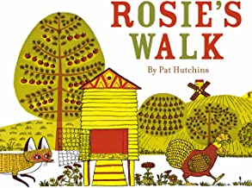 | Use different prepositions in different ways ‘on, around, under, through, behind,’  Children leave spaces between words when they are writing,  Children are able to join words and clauses using ‘and’,  Children are beginning to punctuate sentences using a capital letter, full stop,  question mark or exclamation mark,  Adding the endings –ing, and -ed where there is no change to the root word,  Children use a capital letter for names of people, places, days of the week and the pronoun ‘I’  *Using spelling rules and common exception words taught so far (see Phonics and Spelling Overview) | To write sentences that make sense including a preposition.  To create own picture map to retell Rosie’s Walk  To write/retell the story of Rosie’s Walk | To innovate and write your own ‘Rosie’s Walk’, | - Small world farm set including characters from Rosie’s Walk- could add different textured cereals to support and extend vocabulary use e.g. adjective use: crunchy, hard, dry, brittle, crackly, snapping, rough, grainy. Adding different characters, alongside the familiar encourages children to innovate.  - Recreate the pond from Rosie’s Walk or visit a pond- what lives in here? Link to Science animals and habitats work- an opportunity to revisit specific Vocabulary and concepts e.g. frog life cycles. Vocabulary: frogspawn, tadpole, lilypad, goldfish, pond skater, water boatman, pond weed, pond snail  Investigate what a mill is- children to investigate different types of flour- explore textures and devlop Vocabulary through this e.g. smooth, grainy, lumpy, fine, powdery, seeded, soft, silky, snowy white. Make bread from this and further develop Vocabulary: knead, rise, bake, stretchy, bendy, yeast, teaspoon, sugar, salt, flour, measure, weigh  Create own drama retelling of Rosie’s walk for Harvest Festival-linking to breadmaking and the mill.
Aut B (1) | The Rainbow Fish by Marcus Pfister  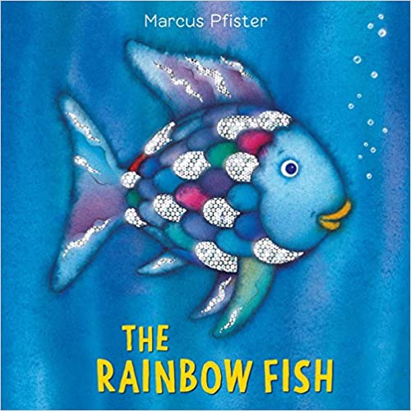 | Use adjectives to describe appearance and personality  Children are able to join words and clauses using ‘and’  Adding the endings –ing, and -ed where there is no change to the root word  *Using spelling rules and common exception words taught so far (see Phonics and Spelling Overview) | To write a character description for Rainbow Fish  To write their own Rainbow Fish story (retelling) | To write instructions on how to care for a rainbow fish | - Making a rainbow fish collages (individual and/or big shared)  - Creating big instructions on how to be a good friend or circle time  - Learning about sea creatures through small world, videos, non fiction texts.  - Construct their own small world ‘sea worlds’  - Sharing games ‘my turn, your turn’  - Describing worlds for rainbow fish (using adjectives from the book to increase vocabulary)  - Looking at how fish move through water (model using flippers and hands as flippers in water.  - Explore the concept of pushing and pulling as forces  Explore what happens to water e.g. water evaporating (disappearing from outside on a sunny day) and investigating ice. Describe the changes when ice melts, asking the question ‘I wonder why?
Aut B (2) | Beegue by Alexis  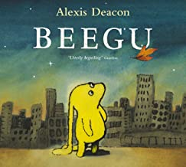 | Y1 written and Reception verbal attempting writing using the sounds they hear  To use adjectives to describe e.g. Beegu had flapping ears.  Children leave spaces between words when they are writing  Children are able to join words and clauses using ‘and’  Children are beginning to punctuate sentences using a capital letter, full stop, question mark or exclamation mark | Y1 written and Reception verbal attempting writing using the sounds they hear or as part of a shared write  To write a character description of Beegu  To Write a diary entry as Beegu | To write a postcard to Beegu | - A spaceship landing to stimulate discussion and interest:  - Children could make their own spaceships to travel to space. Vocabulary: space, travel, fly, launch, rocket, explore, blast, zoom  - Exploring the planets and different worlds e.g. a mars ‘red planet’ world for the children to explore. Vocabulary: dust, rusty, red, sandy, rocks,  - Children could design their own alien puppets with different features. Vocabulary: creepy, slimy, scary, amazing, beautiful, loud, quiet, gentle, vicious
Aut B (3) | Snowflakes  Snowflakes, snowflakes  Twirl around  Snowflakes, snowflakes  Touch the ground  Snowflakes, snowflakes  Land on my nose  Snowflakes, snowflakes  Freeze my toes  Snowflakes, snowflakes  In the air  Snowflakes, snowflakes  Everywhere! | Y1 written and Reception verbal attempting writing using the sounds they hear  Use adjectives to describe snowflakes and snow e.g. icy, snowy, delicate, fragile, melting  Describe actions for snowflakes (verbs) e.g. flutter, swirl, twist, touch, land, dancing | Y1 written and Reception verbal attempting writing using the sounds they hear or as part of a shared write  To perform the Poem including actions  To write sentences to describe snowflakes  Create snowflake poems:  Snowflakes, snowflakes,  Spinning, swirling,  Snowflakes, snowflakes,  Touching, twirling | Poetry performance at Christmas service | - Exploring ice and fake snow- how does this feeling, what does it look like? Vocabulary- icy, freezing, smooth, shiny, watery, melting, squishy…  - Creating own snowflake patterns  - Moving like snowflakes. Vocabulary- swirling, whirling, dancing, spinning, twisting, floating, touching
Spring A (1) | The Owl Babies by Martin Waddell  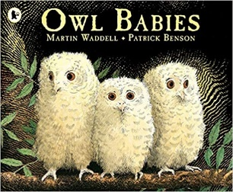 | Y1 and Reception Verbally: To use verbs to describe how the owls moved e.g. The owl glided through the air.  The owl shuffled along the branch.  To use adjectives to describe how the owls were feeling e.g. the baby owls were frightened, terrified, relieved, ecstatic  Adding ‘er’ and ‘est’ to the end of a word, where no change is needed to the root of a word e.g. big, bigger, biggest in describing the owls.  Y1 Children leave spaces between words when they are writing  Children are able to join words and clauses using ‘and’  Children are able to punctuate sentences using a capital letter, full stop, question mark or exclamation mark most of the time.  Adding the endings –ing, and -ed where there is no change to the root word e.g. swooping/swooped, flying.  *Using spelling rules and common exception words taught so far (see Phonics and Spelling Overview) | Y1/Reception: To retell the story of the owl babies  Y1 and Reception using a writing frame:  To write a nocturnal animal fact file  Y1 and reception shared writing piece: To write a recount on investigating an owl pellet e.g. what did you do and what did you find out? | Nocturnal animal factfile | - Build a home for an owl using big construction/natural materials. Children need to think carefully about what they may need.  - Retell the story of the Owl Babies using story mapping . Children to create their own story maps, adding labels and beginning to build sentences. Vocabulary: swoop, glide, lonely, sad, frightened, nervous, love, happy, joy, excited, snowy, feathery,  - Learn about Owl habitats, diet and appearance. Make posters to share learning with labels  - Circle time to explore challenges and resilience. Vocabulary: feelings- nervous, happy, sad, frightened, alone
Spring A (2) | The Gingerbread Man  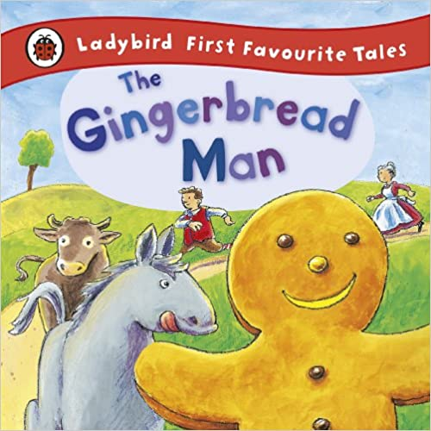 | Y1 and Reception Verbally:  Use conjunctions of time First, Then, Next, After that, Finally to verbally share instructions and then to write  Use bossy verbs e.g. mix, stir, cut, roll  Children leave spaces between words when they are writing  Children are able to join words and clauses using ‘and’  Children are able to punctuate sentences using a capital letter, full stop, question mark or exclamation mark most of the time. | Y1  To write instructions for making gingerbread men  Y1/Reception:  To act out the story of the gingerbread man (using puppets)  Y1  To write the story of the gingerbread man using a comic strip presentation (adding speech bubbles and pictures)  Reception to draw the different events in the story and then write phrases to describe, using writing frames where needed | To write the story of the gingerbread man using a comic strip presentation (adding speech bubbles and pictures) | - Baking gingerbread men and practising using bossy verb vocabulary e.g. mix, stir, sprinkle, put, measure, roll, cut.  - Play dough gingerbread men instructing others how to make a gingerbread man: Vocabulary- first, then, next, after that, push, squish, roll, combine, cut, put  - Small world gingerbread men to support retelling with sentences and repetitive refrains available  - Percussion instruments out to retell e.g. cow bell for cow, coconut halves for the horse and then a drum to hold the steady beat (pentameter) of the repetitive refrain: ‘run, run as fast as you can you can’t catch me I’m the Gingerbread Man’.
Spring B (1) | Rainbow Stew by Catherine Falwell  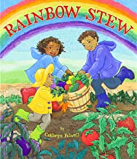 | Y1 and reception (differentiated by language use) : Use adjectives to describe a fruit or vegetable e.g. shiny pepper, glossy tomato, bitter lemon, sweet strawberry, tart raspberry  Y1 and Reception (differentiated by language use and spelling/phonic expectation): Using imperative ‘bossy’ verbs  Y1 and reception verbally and seen modelled within writing frame: Using conjunctions of time e.g. first, then, next, after that and finally | Y1 and Reception (differentiated by language use and spelling/phonic expectation): Write descriptive sentences to describe a fruit or vegetable to go on display to encourage children to try new foods  Y1 and Reception (differentiated by language use and spelling/phonic expectation): Write a recount of how you made rainbow stew using imperative ‘bossy’ verbs and time connectives | Y1 and Reception as a small group piece:  Create a poster to share the importance of healthy eating with key facts and captions included as well as images (photographs and pictures). This will be shared with parents and the school | Children explore and discuss different vegetables. Vocabulary: smooth, bumpy, rough, hard, shiny, colourful, bitter, sweet, sharp, juicy, moist  Children make rainbow stew, after tasting and preparing vegetables. Encourage children to create a picture instruction list (preschool adding in initial sounds if appropriate e.g. ‘c’ for carrot)  Vocabulary: mix, add, chop, stir, combine, measure, weigh  Children explore colour mixing through painting and colour mixing sensory bags  Explore healthy eating and ‘eating the rainbow’  Vocabulary: healthy, sweet, bitter, sharp, like, dislike, juicy, sugar, colourful,  Picking up and sorting rainbow beads (using pincers), making rainbow necklaces (threading)  Setting up and role playing cafes. Adults to provide mark making opportunities (e.g. rainbow pens and menus, notepads and name cards). Model writing and encourage hearing and recording initial sounds, as well as emergent writing and whole word writing.  Visit Africa on Google Earth. Share videos or pictures of the different people who live there and terrain/land e.g. the Serengeti and Congo Rainforest.
Spring B (2) | Harry and his bucketful of dinosaurs by Ian Whybrow  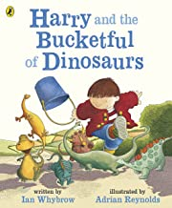 | Y1 and reception (differentiated by language use) To use adjectives to describe dinosaurs and the places visited (settings)  Children leave spaces between words when they are writing  Children are able to join words and clauses using ‘and’  Children are able to punctuate sentences using a capital letter, full stop, question mark or exclamation mark most of the time.  Adding the endings –ing, and -ed where there is no change to the root word e.g. the dinosaur jumped out of the bucket…Harry leaped down the road.  Adding ‘er’ and ‘est’ to the end of a word, where no change is needed to the root of a word e.g. tall, taller, tallest in describing and comparing the dinosaurs | To create a dinosaur fact poster  To plan and write a ‘Harry’ adventure story | Y1-To write an adventure story with you instead of Harry (third person, past tense).  Reception: To write a beginning, middle and end story writing captions and simple sentences to describe/ | Small world dinosaur land inside and out  Vocabulary: ferocious, huge, colossal, giant, vicious, sharp, clawed, tail, spines, spikes, plates, tubes  Buckets and containers with different capacities to support bossy verb use. Vocabulary: fill, pour, tip
Summer A (1) | Jack and the Beanstalk  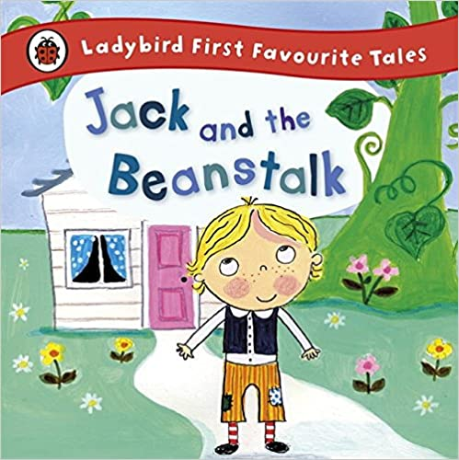 | Y1 and Reception (differentiated through language use and phonic expectation)  Using adjectives to describe the beanstalk e.g. towering, ginormous, vast  Y1 and Reception (differentiated through language use and phonic expectation)  Using verbs to describe how the characters did things e.g. the giant bellowed, Jack sprinted, the cow ambled…  Children leave spaces between words when they are writing  Children are able to join words and clauses using ‘and’  Children are able to punctuate sentences using a capital letter, full stop, question mark or exclamation mark most of the time.  Adding the endings –ing, and -ed where there is no change to the root word e.g. Jack sprinted to the beanstalk.  Adding ‘er’ and ‘est’ to the end of a word, where no change is needed to the root of a word e.g. the beanstalk grew taller and taller or Jack ran faster and faster or it was the biggest beanstalk the world had ever seen! | Retell the story of Jack and the Beanstalk  Sensory and imaginative story writing: Imagine if a Beanstalk appeared in our school, where would it take you? What would you see? Who would you meet? What would you do?  Designing a wanted poster for the giant | Writing own sensory narrative to tell the story of ‘ourselves’ and the Beanstalk e.g. Evie and the Beanstalk | - Growing Beans, observing, drawing and recording. Vocabulary: grow, leaves, bean, water, soil, sunlight, tall, taller, tallest, small, smaller, smallest; smooth, shiny, speckled bean  - Exploring and describing characters e.g. Jack and the Giant. Vocabulary: angry, huge, colossal, immense, frightening, scary, booming/loud voice  - Making Character Wanted posters.  - Building a beanstalk using anything you like e.g. how can you reach the clouds?
Summer A (2) | How to Catch a Star by Oliver Jeffers  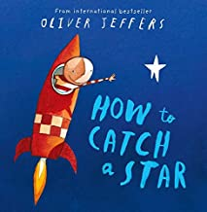 | Y1 and Reception (differentiated through language use and phonic expectation)  Using adjectives to describe alien appearance e.g. gloopy, jelly- like, glowing, glistening, shining  Y1 and reception (working towards): Children leave spaces between words when they are writing  Y1: Children are able to join words and clauses using ‘and’  Y1: Children are able to punctuate sentences using a capital letter, full stop, question mark or exclamation mark most of the time.  Y1: Adding the endings –ing, and -ed where there is no change to the root word e.g. The boy blasted off into space.  Y1: Adding ‘er’ and ‘est’ to the end of a word, where no change is needed to the root of a word e.g. it was the fastest rocket in the Solar System! | Y1  Write own instructional text on ‘how to catch a star’  Reception- write instructional sentences  Y1 (extend thinking and sentences to explain why)  and Reception: Write a list of things you would need to take with you on a rocket journey to space. | Y1 and Reception (differentiated by expectation in vocabulary and written transcription):  Create a ‘wanted’ poster for an alien (based on own designed and made aliens) | Making own solar systems out of polymer clay. Vocabulary: gas, planet, star, sun, space, moon, orbit, Jupiter, red spot, storm, ice and dust, Saturn, Mars, Earth, oceans and land  Exploring star constellations-making own  Vocabulary: Orion, Little Bear, big bear, star, the plough, Gemini, Leo,
Summer B (1) | The Tiny Seed by Eric Carle  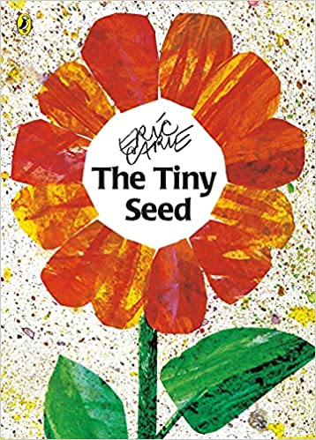 | Y1 and Reception (differentiated through language use and phonic expectation)  Adjectives to describe different flowers, how they smell, feel, look like… e.g. delicate petals, beautiful smell, vibrant/bright colour  Y1 and reception (Y1 written expectation to include to give coherence to writing:  Using conjunctions of time to explain the life cycle of a flowering plant e.g. first, secondly, thirdly, then, next, after that and finally.  Y1 and reception (working towards): Children leave spaces between words when they are writing  Y1: Children are able to join words and clauses using ‘and’  Y1: Children are able to punctuate sentences using a capital letter, full stop, question mark or exclamation mark most of the time. | Writing explanations to include diagrams/pictures and photos to describe the life cycle of a seed  Flower descriptions- exploring different flowers, learning their names and describing them using adjectives (could be added as captions to a display of painted flowers) | Written explanation of the life cycle of a flowering plant | - Planting seeds and observing how these grow, learning what they need to stay healthy. Children to question why and how things happen when plants grow. Adult to model this: ‘I wonder why…’  - Use tools for digging e.g. looking for seeds in the soil, digging holes to plant seeds. Children to care for tools.  - Travel like seeds-modelling seed dispersal. Growing from tiny seed into a plant (music and movement)  - Children explore the book, taking turn to act out different parts  - Writing labels for plants and seedlings and setting up their own shop to sell plants  - Counting Seeds and Comparing
Summer B (2) | Sing a Song of Sixpence  Sing a song of sixpence,  A pocket full of rye.  Four and twenty blackbirds,  Baked in a pie.  When the pie was opened,  The birds began to sing;  Wasn't that a dainty dish,  To set before the king?  The king was in his counting house,  Counting out his money;  The queen was in the parlour,  Eating bread and honey.  The maid was in the garden,  Hanging out the clothes;  When down came a blackbird  And pecked off her nose.  If You Should Meet a Crocodile  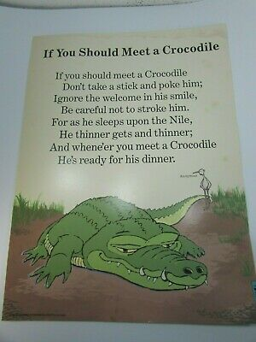 | Y1:  Adding –ed and –ing endings to verbs e.g. opened, counting, hanging, pecked.  Y1 and reception (working towards): Children leave spaces between words when they are writing  Y1: Children are able to join words and clauses using ‘and’  Y1: Children are able to punctuate sentences using a capital letter, full stop, question mark or exclamation mark most of the time. | Y1 and Reception: To understand the meaning behind a traditional poem e.g. what is a sixpence, four and twenty, a parlour, a counting house?  Y1 and Reception (differentiated by phonic expectation)  To bring Sing a Song of Sixpence to life by drawing pictures to match each line so that the ‘old fashioned vocabulary’ is clearly understood for a reader.  To change key words to innovate Sing a Song of Sixpence e.g. Four and Twenty caterpillars  To perform a humorous poem using percussion instruments | Y1 (to have the speaking parts) and Reception: To perform a poem, with instruments and actions to an audience (end of year service) | Sing a song of sixpence- unpicking and exploring what this means- acting out together and creating props.  Pie making, bread making and tasting honey. Making honey bread.  Adding instruments to explore and add sounds to ‘If I should meet a Crocodile’

Cycle 2
 | English Text | Grammar, spelling and punctuation | Learning outcomes | Published Piece | Reception  Adult Directed Suggestions
Aut A (1) | The Little Red Hen  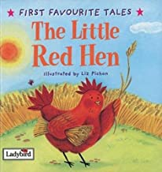 | Y1 and reception verbally  Use different verbs e.g. sowed, planted, baked, threshed  Y1 and reception verbally  Use time connectives e.g. first, then, next, after that, finally.  Y1 -Verbally use adverbial openers- unfortunately, happily, sadly, crossly…  Y1 -Children leave spaces between words when they are writing  Children are able to join words and clauses using ‘and’  *Using spelling rules and common exception words taught so far (see Phonics and Spelling Overview) | Y1/Reception-To create a whole class story map of the story of the Little Red Hen. Y1 using using adverbial openers actively: unfortunately, happily, sadly, crossly…  Y1-To write a retelling of the story of the Little Red Hen, using time connectives e.g. first, then, next, after that, finally.  Y1/Reception-To create a Harvest Performance sharing the story of the Little Red Hen  Y1-To create an illustrated, labelled diagram of a chicken and 2 facts for display. | Y1-To write a retelling of the story of the Little Red Hen, using time connectives e.g. first, then, next, after that, finally. | - Small world farm, including the characters from the Little Red Hen for children to role play  - Different grains, ear of corn, grasses, flour, cereals to explore. Vocabulary (adjectives): crunchy, hard, dry, brittle, crackly, snapping, rough, grainy  - Popcorn flavour tasting (adding different flavours) e.g. toffee, salt, plain, sugar. Children to explore and share tastes and descriptions. Vocabulary (adjectives): sweet, salty, plain, flavourless, sugary. Children to record their favourite popcorn and give a reason why.  - Making own Harvest bread, following instructions. Vocabulary: weigh, measure, teaspoon, yeast, sugar, salt, oil, knead, mix, shape, ball. Children to use pictures to explain what they did. Adult to support with vocabulary and discussion.  - Egg to Chicken lifecycles using the specific vocabulary e.g. in an egg there is the white and the yolk. Children to explore how these develop into chicks using images to show the progression of embryo development.  - Children to draw own egg-chicken lifecycles and record what they see using pictures. Adult to support and challenge through discussion and vocabulary.
Aut A (2) | Storm Whale by Benji Davies  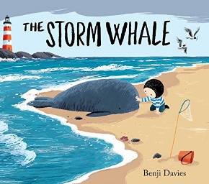 | Y1 written and Reception verbally-Use different prepositions in different ways ‘on, around, under, through, behind,’  Y1 and reception verbally-using adjectives to describe the sea  Y1-Children leave spaces between words when they are writing,  Y1-Children are able to join words and clauses using ‘and’,  Y1-Children are beginning to punctuate sentences using a capital letter, full stop,  question mark or exclamation mark,  Y1-Adding the endings –ing, and -ed where there is no change to the root word e.g the storm whale breached the surface of the sea or the storm whale was washed up on the beach,  Children use a capital letter for names of people, places, days of the week and the pronoun ‘I’  *Using spelling rules and common exception words taught so far (see Phonics and Spelling Overview) | To write a guide on how to care for a beach whale using (book or film)  Designing a game for Noi using instructions  To write a poem about the sea using adjectives to describe  Retelling the story of the Storm Whale  Display- save our whales! | To write an ‘adjective’ poem about the sea | - Gather props and objects that support a seaside theme and provide sensory stimulus to enrich language, such as: driftwood, rocks and pebbles, wet and dry sand, shells, seaweed, salt water and perhaps small world figures with which the children could re-enact the story. They could also create their own.  - Making our own different type of whale using clay and other medi- sperm, blue, killer, Narwhal, humpback, beluga. Vocabulary: blow hole, fins, dorsal fin, ear, eye, flukes, ventral pleats and flippers  - Seaside roleplay using the sandpit. Build and create together a big bank of sand and digging words e.g. dig, spade, mix, pour, pat. To be laminated and stuck up for others to use.  - Investigating different seashells and learning their names and ‘how they lived’ e.g. muscles attached to rocks, limpets cling to rocks, dog whelks and sea snails. Children to draw observational drawings.  - Show box aquariums. Children can play a describing game with these, where they turn the box around and have to describe a sea creature using adjectives for the class to guess what it is.
Aut B (1) | The Hibernation Hotel by John Kelly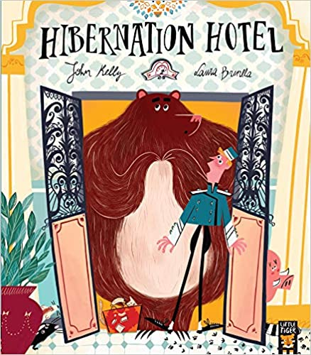 | Use adjectives to describe appearance and personality of characters  Y1-Children are able to join words and clauses using ‘and’  Y1-Adding the endings –ing, and -ed where there is no change to the root word  *Using spelling rules and common exception words taught so far (see Phonics and Spelling Overview) | Y1 individual and reception (shared write book) To retell the story of the Hibernation Hotel-making your own book  Y1 individual and reception (shared write) To write a non-chronological report on one of the animals from the Hibernation Hotel. Children will need to understand about headings (e.g. appearance, diet, habitat, special facts)  Y1 and reception- Making own recording/film about different types of bears to share with other children. | To write a non-chronological report on one of the animals from the Hibernation Hotel | - Role playing hotels. Children to have opportunities to mark make, check in, check out. Add in keys, writing materials, bedding, hotel packs of soap, tea and sugar.  - Making homes for animals that need to hibernate now the weather is getting colder e.g. hedgehog homes, dormouse and bat boxes and putting up around school.  - Learning about different types of bears, their homes and habitats e.g. where does a brown bear live? Vocabulary: Arctic, Polar Bear, brown bear, bespectacled bear, sun bear, moon bear, fur, sharp claws,  - Making our own different bear sock puppets for a recording to teach other children about bears.  Different bear habitats in the tough spot e.g. arctic world with polar bears and polar animals, panda bears and Bamb
Aut B (2) | Grandad’s Secret Giant by David Litchfield  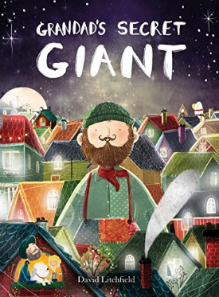 | Y1 written and Reception verbal attempting writing using the sounds they hear  To use adjectives to describe characters and settings  Y1-Children leave spaces between words when they are writing  Y1-Children are able to join words and clauses using ‘and’  Y1- Children are beginning to punctuate sentences using a capital letter, full stop, question mark or exclamation mark | Y1-Explore the different characters, feelings and actions- use this to write character descriptions  Y1 and reception as a shared write-Write simile poems to describe the characters e.g. the giant had hands as large as saucers  Y1 individual and reception as a group-Make up our own stories entitled ‘Grandad’s Secret …….(unicorn, dragon etc)  Y1-Write a diary entry from Billy- the day he first saw the giant | Write your own story about a magical secret character e.g. a secret unicorn or dragon | Create own wave pictures inspired by: Hokusai- The Great Wave, or Turner- Dutch Fishing Boats In A Storm. Vocabulary: foamy, swirling, whirling, enormous, ginormous, huge, colossal, giant. Explore simile verbally e.g. the waves are blue like the sky.  Comparing and contrasting objects and amounts to gain an understanding of size e.g. small, medium, large, tiny, middle sized, giant, huge, enormous, colossal, ginormous.  Designing our own friendly giants. What are our giants like? Adding describing words using developing phonics knowledge.
Aut B (3) | Christmas Baking   | Y1 and Reception  Use bossy verbs to instruct each other what to do e.g. mix, stir, add, measure, pour.  Y1 and reception verbally  Use time connectives e.g. first, then, next, after that, finally. | Y1 and Reception as a shared write-  Write instructions for baking to share with families at home, so that they can rebake! | Y1 and Reception as a shared write-  Write instructions for baking to share with families at home, so that they can re-bake! Use pictures and sentences (inc bossy verbs and time connectives) | Playdough to be able to role play and instruct others. Adults to model vocabulary: add, measure, mix, roll, cut, pour, knead.
Spring A (1) | River Lullaby by Matt Goodfellow  Sliding through the silence of high night peaks  hush little shush little  rush little river  Swallowing secrets that the moon-child speaks  hush little shush little  rush little river  Silver-line dreams where cityscapes sleep  hush little shush little  rush little river  Rumble ever onwards - It's a journey to be free  hush little shush little  rush little river  Back into the arms of a dawn-dressed sea  hush little shush little  rush little river | Y1 written and Reception verbal attempting writing using the sounds they hear  Y1 and reception (differentiated by language use)-Use adjectives to describe a river (5 senses)  Y1 and reception (differentiated by language) Describe movement for river (verbs) e.g. bubbling, babbling, crashing, flowing, swirling, curling  Y1-Adding the endings –ing, and -ed where there is no change to the root word e.g. curling, flowing,  Y1 Children leave spaces between words when they are writing  Children are able to join words and clauses using ‘and’  Y1-Children are able to punctuate sentences using a capital letter, full stop, question mark or exclamation mark most of the time.  *Using spelling rules and common exception words taught so far (see Phonics and Spelling Overview) | Y1 and Reception-To perform River Lullaby using percussion and actions  To write about the Journey of the River Leadon.  To write a poem using adjectives to describe what can be heard, seen, touched  What can be found in a stream or a river? Fact writing and labelled diagrams. | Y1 with sentences to describe each stage and reception (pictures) -To write a story map/journey of the River Leadon | - Create our own water ways and ‘rivers’ using guttering etc. Vocabulary: river source, flowing, moving, waves, ripples, transport, float, sail, meander, bend, ocean  - How to catch water? Exploring using rain gauges and making our own. Children gaining an understanding that this water has come from the seas, rivers…(water cycle). Children to use labelled pictures/diagrams to show what they did.  - Percussion instruments to explore water making sounds  - Moving like water-meandering, flowing, waves, ripples etc…  - What do we find in streams and rivers- stream dipping at Glynch brook. Recording what you see with labels
Spring A (2) | The World Around Me by Charlotte Guillian  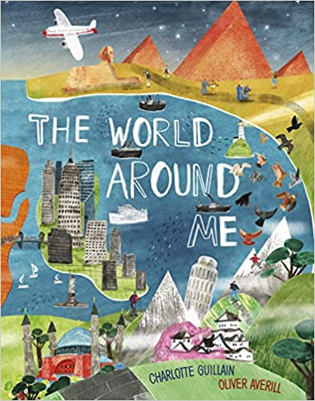 | Y1 and Reception Verbally:  To use adjectives to describe the places we visit and the sights we see e.g. the majestic Taj Mahal or the colossal Himalayas,  Y1-Adding ‘er’ and ‘est’ to the end of a word, where no change is needed to the root of a word e.g. in comparing different landmarks e.g. the Malvern hills are big, Ben Nevis is bigger and Mount Everest is the biggest.  Y1 Children leave spaces between words when they are writing  Children are able to join words and clauses using ‘and’  Y1-Children are able to punctuate sentences using a capital letter, full stop, question mark or exclamation mark most of the time.  Y1-Adding the endings –ing, and -ed where there is no change to the root word e.g. visited, landed, seeing  *Using spelling rules and common exception words taught so far (see Phonics and Spelling Overview) | Y1-To write our own journey around the world including 6 stops, creating our own fold out book. Reception to draw and attempt to write labels and captions to describe the places.  Y1 (full sentence descriptions) and reception (captions and labels to pictures)To write facts about different animals, landmarks and places around the world to add to our own drawings of the world. | Y1-To write our own journey around the world including 6 stops, creating our own fold out book. Reception to draw and attempt to write labels and captions to describe the places. | Children to create their own journey around the world, adding in 3 stops and captions to describe to create their own book  Children to draw pictures of and write labels and facts about the different animals, places and landmarks.  Small world places from around the world- where will we go this week? Africa, Asia, Europe… Different tuff spot places, animals and landmarks to explore. Vocabulary for each e.g. Antarctica- cold, ice, polar bear, arctic fox/hare, snow, melt, ice bergs.  Maps of the world available with tracing paper, chalks and other marks making/drawing opportunities linked to this.
Spring B (1) | What the Ladybird Heard by Julia Donaldson  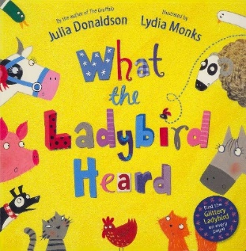 | Y1 and Reception Verbally:  Use verbs to describe actions e.g. the duck flapped in the pond or the cow chewed grass in the field.  Y1-Children leave spaces between words when they are writing  Y1-Children are able to join words and clauses using ‘and’  Y1-Children are able to punctuate sentences using a capital letter, full stop, question mark or exclamation mark most of the time. | Y1 and Reception (attempt captions) Retell the story of what the Ladybird Heard, focusing on the key events and characters.  Y1 and Reception -Create a wanted poster for Hefty Hugh and Lanky Len  Y1-Create a character profile, using adjectives to describe appearance and personality | Retell the story of what the Ladybird Heard, focusing on the key events and characters. | Create a class rhyming dictionary.  Beebot journey to tell the story of What the Ladybird Heard. Adult to support with language use/intonation and expression and adopting different voices for characters. e.g. Hefty Hugh says ‘good thinking that’  Role playing and retelling the story using masks. Children to be encouraged to say lines as their character. Adult to model correct intonation and expression.
Spring B (2) | Aliens love Underpants by Claire Freedman  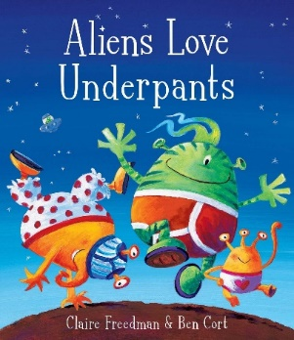 | Y1 and reception (differentiated by language use) : Use adjectives to describe a fruit or vegetable e.g. shiny pepper, glossy tomato, bitter lemon, sweet strawberry, tart raspberry  Y1 and Reception (differentiated by language use and spelling/phonic expectation): Using imperative ‘bossy’ verbs  Y1 and reception verbally and seen modelled within writing frame: Using conjunctions of time e.g. first, then, next, after that and finally | Y1 -Writing your own alien adventure story  Y1 and reception (design with labels)-Designing your own alien and writing a character description to tell the reader more.  Y1-Writing a letter to your alien, using the correct layout and tense. | Y1 independent and reception group write-Writing a letter to your alien, using the correct layout and tense. | Sequence the story using pictures and props  Add in sentences to build a class ‘big book’ of the story.  Design your own aliens, adding two adjectives in a caption to describe.  Describing alien pants and designing your own! Using adjectives to describe and write.  Add speech/thought bubbles to the alien pictures to describe what they are saying or thinking.
Summer A (1) | Chocolate Cake by Michael Rosen  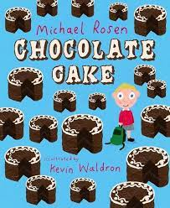 | Y1 and reception (differentiated by language use) To use adjectives to describe chocolate e.g. melting, oozy, thick, sweet, smooth, glossy,  Y1 and reception verbally -Use bossy verbs e.g. mix, stir, put, pour etc.  Y1 and reception verbally  Use time connectives e.g. first, then, next, after that, finally.  Y1-Children leave spaces between words when they are writing  Y1-Children are able to join words and clauses using ‘and’  Y1-Children are able to punctuate sentences using a capital letter, full stop, question mark or exclamation mark most of the time. | Y1 and reception (ingredients list only) Write your own invented recipe for a Chocolate cake (children to have explored making chocolate cake and to also have been read a section of George’s Marvellous Medicine). What unusual ingredients might you add? Children to write ingredients list.  Write your own method for making chocolate cake.  Writing your own sensory chocolate cake poem based on when you first see, then smell and then taste the cake.  Perform poems with expression, intonation, gesture and actions. | Y1- Write your own recipes and method for making chocolate cake to go on our school FB or website to share with parents and others. Reception- ingredients list only | Making own chocolate cake, writing down ingredients. Vocabulary: smooth, silky, melting, chocolate, cocoa, powder, flour, sugar, sweet, sticky, gooey, buttery, mix, combine, stirring, measure, weigh  Making own innovative chocolate cakes in the mud kitchen- what will you add? Remember we need to write it down to be able to make it again!  Making own group poem using adjectives to describe chocolate cake. Add in actions, gestures, facial expressions. Perform to others
Summer A (2) | The Skies Above my Eyes by Charlotte Guillain  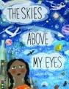 | Y1 and Reception (differentiated through language use and phonic expectation)  Using adjectives to describe the what we can see e.g. vast, huge sky, immense space, sparkling stars, fiery sun,  Y1 and Reception (differentiated through language  Y1-Children leave spaces between words when they are writing  Y1-Children are able to join words and clauses using ‘and’  Y1-Children are able to punctuate sentences using a capital letter, full stop, question mark or exclamation mark most of the time.  Y1-Adding ‘er’ and ‘est’ to the end of a word, where no change is needed to the root of a word e.g. the moon is bright, the stars are brighter and the sun is brightest. | Y1 and Reception (differentiated by phonic expectation) Children to write about what they can see in the city scene imagining that they are the little girl.  Y1 and Reception (differentiated by phonic expectation) Children to write what they see when they look up outside our school. Focus on adjective use to describe.  Children to research and write a factual text about a planet in the Solar System. | Y1 and Reception (draw and captions to describe)- Writing a setting description-Children to write about what they can see in the city scene imagining that they are the little girl. | Children to lie down outside and to look up. What do they see? Write and draw what you saw.  Making own solar systems out of polymer clay. Vocabulary: gas, planet, star, sun, space, moon, orbit, Jupiter, red spot, storm, ice and dust, Saturn, Mars, Earth, oceans and land
Summer B (1) | Whatever Next by Jill Murphy  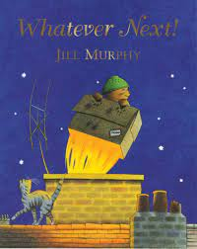 | Y1 and Reception (working towards)  Use verbs to describe the actions e.g. the rocket blasted off!  Y1: Children are able to join words and clauses using ‘and’  Y1: Children are able to punctuate sentences using a capital letter, full stop, question mark or exclamation mark most of the time.  Y1: Adding the endings –ing, and -ed where there is no change to the root word e.g. The bear launched off into space.  Y1: Adding ‘er’ and ‘est’ to the end of a word, where no change is needed to the root of a word e.g. it was the fastest rocket in the Solar System! | Y1 and reception-Retell the story of Whatever Next  Y1-Innovate and write your own story, wondering where would you visit? What would you see? What would happen? Who might you meet? | Y1-Innovate and write your own story, wondering where would you visit? What would you see? What would happen? Who might you meet?  Reception- to retell the story using simple sentences to describe events | Role play space and rockets  Make own space rockets out of cardboard boxes and junk modelling (large and smaller scale)

Class 2 (Year 2 and 3)

Cycle 1 | English Text | Grammar, spelling and punctuation | Learning outcomes | Published Piece
Aut A (1)  Aut A (2)  Aut B (1) | Vlad and the Great Fire of London by  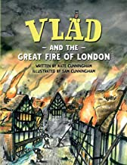  Ruby’s Worry by Tom Percival  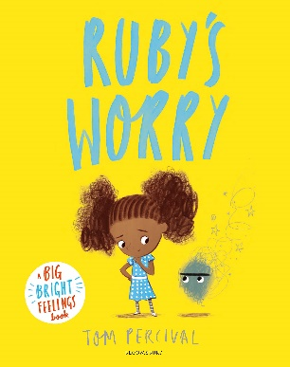  The Tunnel by Anthony Brown  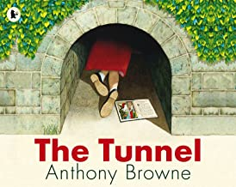 | Y2:  - Children are able to join words and clauses using and, because, but and so  - Children are able to punctuate sentences accurately using a capital letter, full stop, question mark or exclamation mark  - Children know what a noun is (a person, place, object or feeling)  - Children know what an adjective is e.g. the burning fire.  - Children know what a verb is e.g. the burning fire was crackling.  - Children can use subordinating conjunctions e.g. when, because, if  Y3:  - Children can use powerful adjectives in their writing e.g. the flickering flame (Y3)  - Children use apostrophes for possession with confidence e.g. the baker’s oven (Y3)  - Children use inverted commas for direct speech e.g. The girl muttered, ‘I cannot go on any longer…’(Y3)  - Children use coordinating conjunctions e.g. or, and, but (Y3)  - Children use place and cause conjunctions e.g. since, so, yet, therefore (Y3)  Y2:  - Children are able to join words and clauses using and, because, but and so e.g. Ruby was feeling sad because…  - Children are able to punctuate sentences using a capital letter, full stop, question mark or exclamation mark  - Children use a capital letter for names of people, places, days of the week and the pronoun ‘I’  - Children can use subordinating conjunctions e.g. when, because, if (when Ruby shared her worry, she felt better.)  - Children can write expanded noun phrases e.g. the angry  worry…the frightened girl  - Children are able to form nouns from adjectives e.g. happy-happiness and sad-sadness  - Children know what an adverb is e.g. She walked quietly across the park  - Children can use apostrophes for possession e.g. Ruby’s worry  Y3:  - Children use apostrophes for possession with confidence e.g. the boy’s boat  - Children use inverted commas for direct speech e.g. The girl muttered, ‘I cannot go on any longer…’  - Children use coordinating conjunctions e.g. or, and, but  - Children use place and cause conjunctions e.g. since, so, yet, therefore (Ruby was feeling worried, yet she didn’t have the confidence to share this.  Y2  - Children can write expanded noun phrases e.g. the dark tunnel…the gloomy forest  - Children are able to use the progressive forms of verbs to show past and present tense e.g. the girl ran and the girl is running  - Children can use adverbs in their writing is e.g. The girl crawled carefully through the tunnel  - Children are able to join words and clauses using and, because, but and so e.g. the girl was nervous but she carried on anyway!  - Children are able to punctuate sentences using a capital letter, full stop, question mark or exclamation mark  - Children can use subordinating conjunctions e.g. when, because, if (The girl felt proud when she entered the tunnel.)  Y3  - Children can express time, place and cause conjunctions e.g. since, so, yet,  - Children express time, place and cause using adverbs e.g. then, next, therefore  - Children express time, place and cause using prepositions e.g. before, after, during  - Children use expanded noun phrases e.g. she walked through the mysterious, dark forest.  - Children use inverted commas for direct speech e.g. ‘It is so cold and empty in here’ whispered the girl | Pose and ask questions,  Debate-speculating, discussing and hypothesising  Question writing  Diary entry  Comic strips  Discuss and debate feelings and emotions of characters  Diary entry  Character descriptions  Writing letters  Writing 1st person as the worry  Diary entry  Re-telling –narrative  Innovating a story  Descriptive writing  Setting description | Create a comic strip re-telling the story from Boxton’s point of view.  Write a letter to Ruby to give her ways to deal with her worry.  Create a new adventure story based around a tunnel of your own choice.
Spring A (1) | The Journey by Aaron Becker  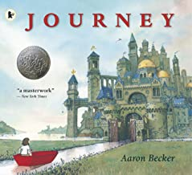 | Y2  - Children are able to join words and clauses using and, because, but and so e.g. the girl was captured because she knew too much!  - Children are able to punctuate sentences accurately using a capital letter, full stop, question mark or exclamation mark.  - Children know what an adjective is and can use expanded noun phrases e.g. the impressive castle  - Children know what a verb is e.g. The impressive castle loomed before her  - Children use a capital letter for names of people, places, days of the week and the pronoun ‘I’  - Children can use subordinating conjunctions e.g. when, because, if (if the girl hurried, she could make it!)  - Children can use apostrophes for possession e.g. the girl’s boat  Y3-  - Children can use adverbs e.g. the cage rattled noisily  - Children can express time, place and cause conjunctions e.g. since, so, yet, (The girl was lonely so she created her own world)  - Children express time, place and cause using adverbs e.g. then, next, therefore  - Children express time, place and cause using prepositions e.g. before, after, during  - Children use expanded noun phrases e.g. glinting, glowing lanterns  - Children can use powerful adjectives in their writing e.g. The glimmering, golden cage | Setting description  Write an adjective poem  Explore adding dialogue and speech bubbles to shoe interactions between characters  Use speech conversations to create a a script  Write a short narrative for the story from one of the character’s points of view (1st person or 3rd person) | Write a narrative sequel to the Journey
Spring A (2) | 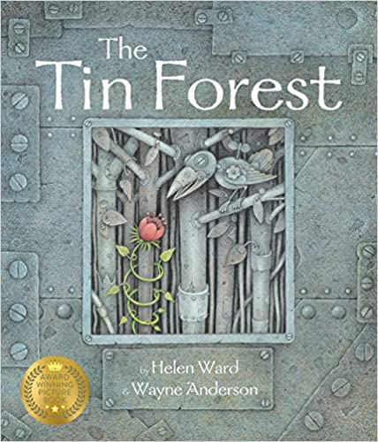  The Tin Forest by Helen Ward | Y2  - Children are able to join words and clauses using and, because, but and so  - Children are able to punctuate sentences accurately using a capital letter, full stop, question mark or exclamation mark  - Children know what a noun is (a person, place, object or feeling)  - Children know what an adjective is and can use expanded noun phrases e.g. the exotic jungle  - Children know what a verb is e.g. The tiger’s eyes were gleaming  - Children can use apostrophes for possession e.g. the man’s book  Y3-  - Children know can use adverbs e.g. The tiger’s eyes were gleaming brightly.  - Children can express time, place and cause conjunctions e.g. since, so, yet, (The old man dreamed of beauty, yet all he had was rubbish!)  - Children express time, place and cause using adverbs e.g. then, next, therefore  - Children express time, place and cause using prepositions e.g. before, after, during (During the night the old man dreamed)  - Children use expanded noun phrases e.g. The cold, metal forest.  - Children can use powerful adjectives in their writing e.g. the delicate flowers…the soothing tiger. | Pose and ask questions, discussing and debating issues raised in the text  Extend vocabulary to write a poem to describe the old man’s dream  Explore character, feelings and emotions  Write a setting description to describe the Tin Forest (before and after) | Write a setting description to describe the Tin Forest (before and after)
Spring B | Izzy Gizmo by Pip Jones  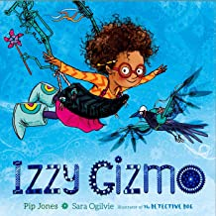 | Y2-  Children are able to join words and clauses using and, because, but and so e.g. you have to turn the handle firmly, so the pasta flattens out.  - Children are able to punctuate sentences accurately using a capital letter, full stop, question mark or exclamation mark.  - Children are able to use conjunctions of time to explain e.g. first you need to…  - Children know what an adjective is and can use expanded noun phrases e.g. The amazing Spagsonic Pasta Machine  - Children know what a verb is e.g. you turn the lever  - Children can use subordinating conjunctions e.g. when, because, if (if you turn the lever the pasta comes out)  - Children can use apostrophes for possession e.g. Izzy’s invention  Y3-  - Children can use adverbs e.g. knead the dough firmly  - Children can express time, place and cause conjunctions e.g. since, so, yet,  - Children express time, place and cause using adverbs e.g. then, next, therefore (next roll the dough out as flat as you can)  - Children express time, place and cause using prepositions e.g. before, after, during (before you roll out the dough, you must knead it)  - Children use expanded noun phrases e.g. sticky, tacky dough… | Verbally explain to another how to use an pasta machine  Write instructions  Write explanations  Write a character description for Izzy  Write a description of one of her inventions | Write an explanation for the great Spagsonic Pasta Machine!
Summer A | Fantastic Mr Fox by Roald Dahl  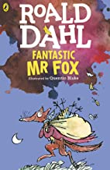 | Y2-  Children are able to join words and clauses using and, because, but and so e.g. Mr fox was absolutely terrified, but he still poked his nose out of the burrow.  Children are able to punctuate sentences accurately using a capital letter, full stop, question mark or exclamation mark.  - Children know what an adjective is and can use expanded noun phrases e.g. the disgusting Bunce  - Children can use different verbs to describe actions e.g. Mr Fox scrambled through the tunnel  - Children can use subordinating conjunctions e.g. when, because, if (the trapdoor opened, when Mr Fox gave it a push)  - Children can use apostrophes for possession e.g. Mr Fox’s children  - Children use inverted commas to punctuate speech and dialogue  Y3-  - Children can use adverbs e.g. Mr Fox crept cautiously out of his burrow  - Children can express time, place and cause conjunctions e.g. since, so, yet, (the small foxes were exhausted, yet they kept on digging)  - Children express time, place and cause using adverbs e.g. then, next, therefore  - Children express time, place and cause using prepositions e.g. before, after, during (before they could feast, they needed to get the food back to Mrs Fox)  - Children use expanded noun phrases e.g. sickly, sweet cider | Use hot seating to explore character  Write a Character description for Mr Fox, Boggis, Bunce or Bean  Write a dialogue between two characters  Recount events from 2 different view points e.g. Mr Fox’s and Badger’s. | Write a newspaper report to cover the events of Fantastic Mr Fox
Summer B (1) | Zahra (Literacy Shed)  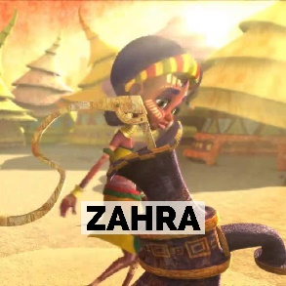 | Y2-  - Children are able to join words and clauses using and, because, but and so  - Children are able to punctuate sentences accurately using a capital letter, full stop, question mark or exclamation mark.  - Children know what an adjective is and can use expanded noun phrases e.g. vibrant dress…stripy facepaint  - To use appropriate adjectives to describe accurately e.g. streaky face paint.  - Use coordinating and subordinating conjunctions  - To understand and use verbs accurately  - To write in past or present tense  - Children use inverted commas to punctuate speech and dialogue  Y3-  - Children use expanded noun phrases e.g. striking, vibrant face paint  - To write in past and present tense accurately  - Children can use adverbs e.g. Zahra shuffled watchfully across the ground  - Children can express time, place and cause conjunctions e.g. since, so, yet,  - Children express time, place and cause using adverbs e.g. then, next, therefore  - Children express time, place and cause using prepositions e.g. before, after, during  - Children use inverted commas to punctuate speech and dialogue consistently and accurately in a piece of writing | Ask (and write) questions and give statements.  character description  Learn to write action sentences  Write and use drama to reenact speech/ dialogue sentences  Narrative opening  3rd person narrative | Children write a narrative in 3rd person

Cycle 1 | English Text | Grammar, spelling and punctuation | Learning outcomes | Published Piece
Aut A (1)  Aut A (2)  Aut B  Spring A (1)  Spring A (2)  Spring B  Summer (1)  Summer A (2) | Hansel and Gretel by Bethan Woollvin  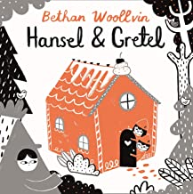  Stone Age Boy by Satoski Kitamura  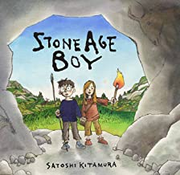  The Iron Man by Ted Hughes  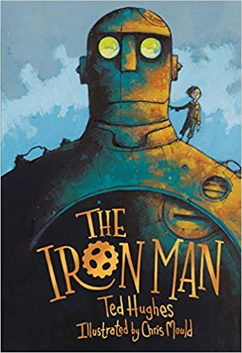  Grandfather’s Journey by Allen Say  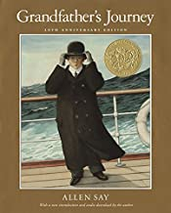  The Proudest Blue by Ibtihaj Muhammad  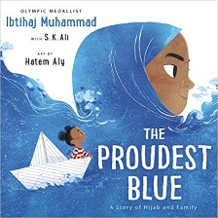  Zoo by Anthony Brown  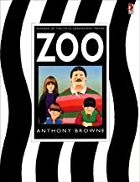  Arthur and the Golden Rope  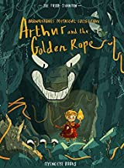  Invasions Unit Literacy Shed   | Y2:  - Children are able to join words and clauses using and, because, but and so e.g. Hansel wanted the sweets because he was so hungry.  - Children are able to punctuate sentences accurately using a capital letter, full stop, question mark or exclamation mark  - Children know what a noun is (a person, place, object or feeling)  - Children know what an adjective is e.g. the sugary sweets.  - Children know what a verb is e.g. the children skipped along.  - Children can use subordinating conjunctions e.g. when, because, if (when Hansel got to the door he turned the handle)  Y3:  - Children can use powerful adjectives in their writing e.g. the meandering path  - Children use apostrophes for possession with confidence e.g. the witch’s cottage  - Children use inverted commas for direct speech  - Children use coordinating conjunctions e.g. or, and, but  - Children use place and cause conjunctions e.g. since, so, yet, therefore  Y2-  - Children are able to join words and clauses using and, because, but and so  - Children are able to punctuate sentences accurately using a capital letter, full stop, question mark or exclamation mark  - Children are able to write in expanded noun phrases  - Children can use an adjective to describe a noun  - Children can use suffix –ly to turn adjectives into adverbs e.g. the boy kindly helped the girl.  - Children can use adverbs to describe verbs in sentences e.g. the boy walked slowly towards the cave.  - Children know what a verb is and can vary these in their sentences e.g. the children strolled along.  - Children can use subordinating conjunctions e.g. The boy stopped still, when the girl beckoned him to follow.  - Children use apostrophes for contractions e.g. I’m, he’s, she’s  Y3-  - Children can use coordinating conjunctions e.g. They stopped to talk to each other, so that they could understand more.  - Children can use subordinating conjunctions to vary their sentences e.g. When the boy spotted the cave, he was very excited.  - Children can write consistently in past and present tense  - Children can write in paragraphs around a theme  - Use apostrophes for possession e.g. the girl’s hand shook nervously.  - Use dialogue punctuation accurately within a narrative  - Children use prepositions in their writing e.g. Under the silvery moon, the deer walked majestically.  - Using personal dictionaries, thesaurus and dictionaries  - Proof reading and revising writing  Y2-  Children are able to join words and clauses using and, because, but and so e.g. The Iron man creaked forward, but he was very slow.  - Children are able to punctuate sentences accurately using a capital letter, full stop, question mark or exclamation mark.  - Children are able to use conjunctions of time to explain e.g. Finally he rested.  - Children know what an adjective is and can use expanded noun phrases e.g. The empty eyes of the Ironman.  - Children know what a verb is and use in their writing e.g. his legs creaked and groaned.  - Children can use apostrophes for possession e.g. The ironman’s fist.  - Children use apostrophes for contractions e.g. he’s  Y3-  - Children can use adverbs e.g. the Ironman walked determinedly towards the boy.  - Children can use simile e.g. the rusted iron like burnished autumn leaves.  - Children recognise metaphor e.g. His great iron head shaped like a dustbin but as big as a bedroom  - Children can express time, place and cause conjunctions e.g. since, so, yet, (The Ironman edged closer, yet still he couldn’t see him)  - Children express time, place and cause using adverbs e.g. then, next, therefore  - Children express time, place and cause using prepositions e.g. before, after, during  - Children use expanded noun phrases e.g. piercing, dagger-like eyes staring  - Children use commas to separate items in a list e.g. the wary, scared look in his eyes.  - Children begin to organise their writing into paragraphs  - Proof reading and revising writing  Y2-  Children are able to join words and clauses using and, because, but and so e.g. The man held tightly onto his hat, so that it didn’t fly away.  - Children are able to punctuate sentences accurately using a capital letter, full stop, question mark or exclamation mark.  - Children are able to use conjunctions of time to explain e.g. After that the man visited the…  - Children know what an adjective is and can use expanded noun phrases e.g. The glistening pool of water.  - Children know what a verb is and use in their writing e.g. the water swirled and curled  - Children can use subordinating conjunctions e.g. when, because, if (the boat shook when the waves hit it)  - Children can use apostrophes for possession e.g. The man’s hat.  - Children use apostrophes for contractions e.g. he’s  Y3-  - Using –ed past tense to build vocabulary e.g. the man marvelled…the man felt bewildered…the man longed for.  - Children can use adverbs e.g. the sea rocked gently to and fro that evening.  - Children can use simile e.g. the water was as still as a sheet of glass.  - Children can express time, place and cause conjunctions e.g. since, so, yet, (The man felt so homesick, since he was far from home)  - Children express time, place and cause using adverbs e.g. then, next, therefore  - Children express time, place and cause using prepositions e.g. before, after, during (Before his journey the man packed his clothes securely in a trunk).  - Children use expanded noun phrases e.g. thrashing, bashing waves.  - Children use commas to separate items in a list e.g. thrashing, bashing  - Children begin to organise their writing into paragraphs  - Proof reading and revising writing  Y2-  - Children are able to join words and clauses using and, because, but and so  - Children are able to punctuate sentences accurately using a capital letter, full stop, question mark or exclamation mark  - Children write in expanded noun phrases  - Children can use an adjective to describe a noun  - Children can use suffix –ly to turn adjectives into adverbs e.g. the old woman stared miserably at the boy  - Children can use the progressive form of verbs e.g. she is drumming…he is driving  - Children can use adverbs to describe verbs in sentences e.g. the lion prowled slowly towards the cave.  - Children know what a verb is and can vary these in their sentences e.g. the children shuffled along.  - Children use apostrophes for contractions e.g. I’m, he’s  - Children can recognise a simile e.g. the sea was like a pool a tears  Y3-  - Children are able to use simile to describe e.g. the hijab is blue like the bluest sky.  - Children can use coordinating conjunctions e.g. Faizah wanted a hijab the same as Aishya’s, because blue was her favourite colour.  - Children can use subordinating conjunctions to vary their sentences e.g. Faizah felt proud of Asiya’s Hijab, but embarrassed that people didn’t understand.  - Children can write consistently in past and present tense  - Children can write in paragraphs around a theme  - Children can use apostrophes for possession with confidence e.g. Asiya’s hijab  - Children use prepositions in their writing e.g. the boat travelled through the deep blue  - Using personal dictionaries, thesaurus and dictionaries  - Proof reading and revising writing  Y2-  - Children are able to join words and clauses using and, because, but and so  - Children are able to punctuate sentences accurately using a capital letter, full stop, question mark or exclamation mark  - Children write in expanded noun phrases  - Children can use an adjective to describe a noun  - Children can use suffix –ly to turn adjectives into adverbs e.g. the old woman stared miserably at the boy  - Children can use the progressive form of verbs e.g. she is drumming…he is driving  - Children can use adverbs to describe verbs in sentences e.g. the lion prowled slowly towards the cave.  - Children know what a verb is and can vary these in their sentences e.g. the children shuffled along.  - Children use apostrophes for contractions e.g. I’m, he’s  Y3-  - Children can use coordinating conjunctions e.g. Dad always tells me off, because I am the oldest! It is not fair!  - Children can use subordinating conjunctions to vary their sentences e.g. When Dad argued with the ticket man, I felt embarrassed!  - Children can write consistently in past and present tense  - Children can write in paragraphs around a theme  - Use apostrophes for possession e.g. Dad commented on the tiger’s sharp teeth’  - Use dialogue punctuation consistently within text  - Children use prepositions in their writing e.g. On top of their heads they wore their monkey hats! The penguins huddled next to the pool  - Using personal dictionaries, thesaurus and dictionaries  - Proof reading and revising writing  Y2-  - Children are able to join words and clauses using and, because, but and so  - Children are able to punctuate sentences accurately using a capital letter, full stop, question mark or exclamation mark  - Children write in expanded noun phrases e.g. the dangerous wolf  - Children can use an adjective to describe a noun effectively e.g. the glimmering crystal.  - Children can use suffix –ly to turn adjectives into adverbs e.g. wickedly  - Children can use the progressive form of verbs e.g. Arthur is running…he is brave.  - Children can use adverbs to describe verbs in sentences e.g. the wolf stalked slowly towards Arthur.  - Children know what a verb is and can vary these in their sentences e.g. Arthur stomped forwards.  - Children can use adverbs e.g. Arthur stomped angrily forwards.  Y3-  - Children can use coordinating conjuctions e.g. because, or, and  - Children can use subordinating conjunctions to vary their sentences e.g. whilst the wolf crept towards him, Arthur thought carefully.  - Children can write consistently in past and present tense  - Children can write in paragraphs around a theme  - Children use prepositions in their writing e.g. in front of his very eyes, the gleaming gem glistened.  - Using personal dictionaries, thesaurus and dictionaries  - Proof reading and revising writing  - Begin to use fronted adverbials in their writing e.g. Bravely Arthur faced the lion, even though his heart was beating frantically in his chest.  Y2-  - Children are able to join words and clauses using and, because, but and so  - Children are able to punctuate sentences accurately using a capital letter, full stop, question mark or exclamation mark  - Children write in expanded noun phrases e.g. glinting, shining ship  - Children can use an adjective to describe a noun effectively e.g. the shrieking sound  - Children can use suffix –ly to turn adjectives into adverbs e.g. lonely  - Children can use adverbs to describe verbs in sentences e.g. the wind was whipping across the land.  - Children can use adverbs e.g. The sun shone strongly down upon the world  Y3-  - Children can use coordinating conjunctions e.g. but, or, and (the alien was frantic and afraid)  - Children can use subordinating conjunctions to vary their sentences e.g. Although I was very nervous, I still opened the door to my ship.  - Children can write consistently in past and present tense  - Children can write in paragraphs around a theme  - Children use prepositions in their writing e.g. Beneath the swirling dust, an alien stood.  - Using personal dictionaries, thesaurus and dictionaries  - Proof reading and revising writing  - Begin to use fronted adverbials in their writing e.g. Fearsomely, the alien let out a powerful roar! | Participate in a performance  Retelling the story with twists  Character description  Writing your own alternative version of the story  Writing a play script of the story  Character description Narrative writing Information writing Diary Entry  Character description/biography  Narrative writing  Instructions on how to capture the Ironman  Persuasive letter  Character description  Setting description  Writing letters  Writing a recount  Articulate and justify answers, arguments and opinions (thinking about the experience of Asiya)  Build vocabulary to describe the sea  Descriptions of the sea setting (using senses)  Retell the story from Asiya’s point of view  Consider and evaluate different viewpoints, attending to and building on the contributions of others (thinking about the views, feelings and experiences of dad, the children and mum)  Character description built around feelings, beliefs, views and experiences  Instructions (how to look after animals)  Writing a poem about my Dad inspired by dad in Zoo  Use drama to tell parts of the story  Describe character  Describe setting  Write a powerful opening paragraph  Character description  description of a settings  Ship log journals | Writing and performing own group play scripts  Narrative adapted Stone Age Boy or Girl  Persuasive letter  Narrative writing piece  Write own poem to describe the sea  Information Booklet (non-chronological report) about animals  Write a diary entry where Arthur first sees the wolf.  Ships Log Journal
Summer B | The Secret Life of Bees by Moira Butterfield  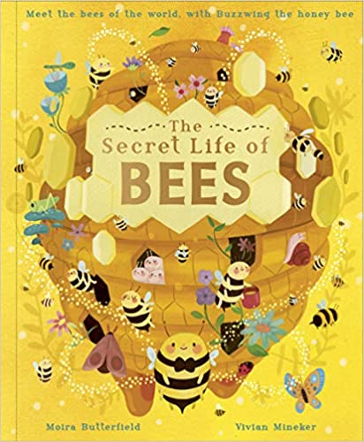 | Y2-  - Children are able to join words and clauses using and, because, but and so  - Children are able to punctuate sentences accurately using a capital letter, full stop, question mark or exclamation mark  - Children can use an adjective to describe a noun effectively e.g. the flickering wings of the bee.  - Children can use adverbs to describe verbs in sentences e.g. the bees flying furiously towards the hive.  Y3-  - Children can use coordinating conjunctions e.g. but, or, and (I would like to keep my honey or why should I make it?)  - Children can use subordinating conjunctions to vary their sentences e.g. Unless we look after our bees we will have no food to eat!  - Children can write consistently in past and present tense  - Children can write in paragraphs around a theme  - Children use prepositions in their writing e.g. Within the beehive the worker bees look after their queen.  - Using personal dictionaries, thesaurus and dictionaries  - Proof reading and revising writing | Poems  Letter from the bee  Retelling a story  Information writing about bees | Information writing about bees

Class 3 (Year 4, 5 and 6)
Cycle A
Term | Quality Text | Grammar, spelling and punctuation | Writing Outcomes | Published Piece
Autumn A/B | Who Let the God’s Out by Maz Evans  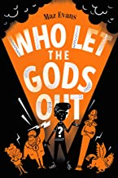 | Fronted Adverbials (All)  Pronoun or noun (All)  Tenses (All)  Expanded noun phrases (All)  Paragraphs (All)  Inverted commas (All)  Synonyms and antonyms (Yr 6)  Linking paragraphs using adverbials (Yr 5/6)  Using commas to clarify meaning (Yr 5/6)  Modifying prepositional phrases (All)  Cohesion within paragraphs (Yr 5/6) | Descriptive writing.  Figurative Language use.  Press release.  Explore sentence construction and the impact clauses have | Third Person Narrative  Newspaper article
Autumn B (1 week mini project) | Christmas Recipe Writing  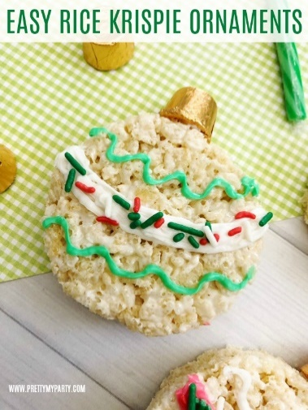 | Layout devices (All)  Fronted Adverbials (All)  Linking paragraphs using adverbials (Yr 5/6)  Using modal verbs to indicate possibility (Yr 5/6) | Descriptive writing  Recipe | Instructions
Spring A | Kensuke’s Kingdom by Michael Morpurgo  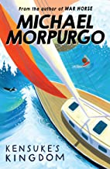 | Modal Verbs (All)  Subordinate clause (All)  Relative Clauses (5/6)  Determiners (All)  Cohesion across paragraphs(Yr 6)  Parenthesis (Yr 5/6)  Hyphens (Yr 6)  Semi-colons, colons and dashes (Yr 6) | Motif poetry  Tanka Poem  Precise text in a timeline  To use figurative language | Narrative  Haiku Poem
Spring B | Macbeth Literacy Shed  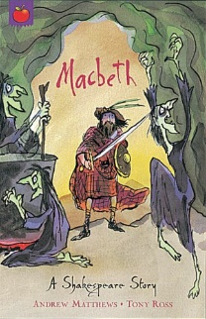 | Pronoun and nouns (All)  Parenthesis (Yr 5/6)  Formal and informal writing (Yr 6)  Using the passive (Yr 6)  Apostrophes (All)  Informal and formal speech (Yr 6)  Standard English ver inflections (All) | Letter.  Sequencing events.  Identifying and writing features in a balanced argument.  Make predictions.  Persuasive techniques. | Newspaper.  Balanced argument.
Summer A | Rose Blanche by Roberto Innocenti  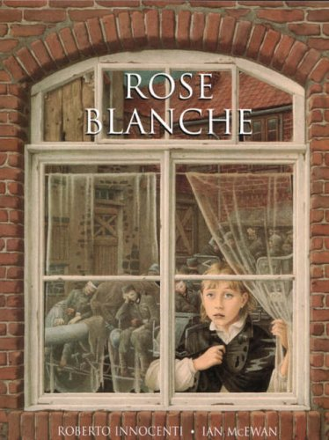 | Relative Clauses (Yr 5/6)  Paragraphs (All)  Parenthesis (Yr 5/6)  Formal and informal language (Yr 6)  Pronouns (All)  Commas to clarify meaning (Yr 5/6)  Plural and possessive ‘s’ (All)  Standard English Verb Inflections (All) | Techniques to build tension and suspense in writing.  To use figurative language  To make predictions  Journey mapping.  Emotive poem. | Setting description.  Internal monologue.  Diary entry
Summer B | Letters from the Lighthouse by Emma Carroll  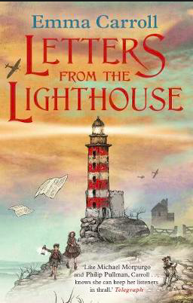 | Using the passive voice (Yr 6).  Hyphens (Yr 6).  Plural and possessive ‘s’ (All).  Tenses (All). | Write a missing person’s report.  Write a descriptive recount.  Persuasive letters.  Poetry. | A persuasive letter  A poem

Cycle B
Term | Quality Text | Grammar, spelling and punctuation | Writing Outcomes | Published Piece
Autumn A | Treason by Berlie Doherty  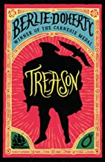 | Synonyms and Antonyms (Yr 6)  Pronoun or noun (All)  Fronted adverbials (All)  Formal and Informal Writing (Yr 6)  Expanded Noun Phrases (All)  Prepositional Phrases (All)  Cohesion within Paragraphs (Yr 5/6) | Character description.  Setting description.  Prediction.  Diary entry.  Narrative story | Diary.  Narrative Story.
Autumn B | Voices in the Park by Anthony Brown  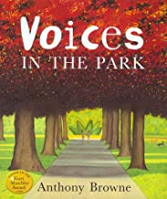 | Using commas to clarify meaning (All).  Paragraphs (All).  Inverted Commas (All). | Poem.  Descriptive language.  Character description  Setting Description.  Book recommendation. | Poem.  Narrative Story.
Autumn B (1 week mini project) | Brownie Trees  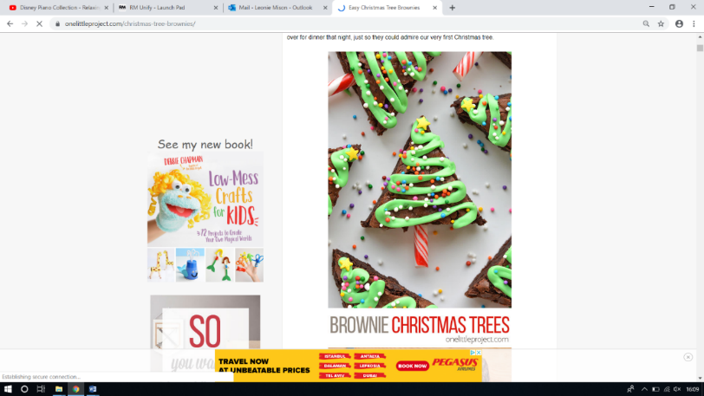 | Layout Devices (All).  Modal verbs to indicate possibility (All).  Semi-colons, colons and dashes (Yr 6) | Recipe (instructional).  Descriptive paragraph. | Recipe
Spring A | Day of the Dead (Literacy Shed)  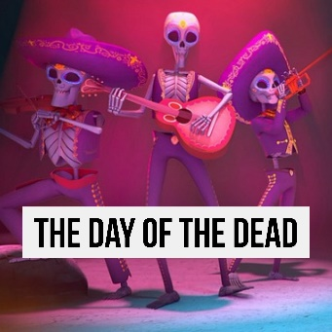 | Using the passive (Yr 6). Commas/brackets/ dashes to indicate parenthesis (Yr 5/6).  Relative Clause (Yr 5/6)  Determiners (All).  Tenses (All).  Linking paragraphs using adverbials (Yr 5/6) | Setting description.  Information leaflet.  Diary extract | Information leaflet
Spring B | Edward Tulane by Kate DiCamillo  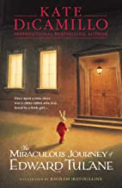 | Hyphens (Yr 5/6).  Cohesion across paragraphs (Yr 6).  Standard English Verb Inflections (All).  Inverted Commas (All).  Formal and informal speech (All)  Plural and Possessive‘s’ (All) | Dream description.  Setting Description.  Missing Person advert. | Rewrite a fairy tale.  Letter
Summer A | Children of the Kingdom of Benin by Dinah Orji  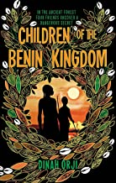 | Apostrophes (All)  Fronted Adverbials (All)  Pronoun or noun (All)  Synonyms and antonyms (Yr 6)  Relative clause (Yr 5/6) | Diary entry  Setting description  Personal account | Letter from father to future daughter.  Narrative from another perspective.
Summer B | Tiger, Tiger Burning Bright (poems) by Fiona Waters  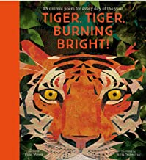 | Expanded noun phrases (All)  Using commas to clarify meaning (Yr 5/6)  Semi-colons, colons and dashes (Yr 6) | Review  Figurative language | Poetry

Cycle C
Term | Quality Text | Grammar, spelling and punctuation | Writing Outcomes | Published Piece
Autumn A | The Alchemist’s Letter  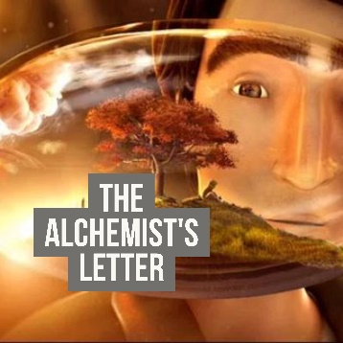 | Modal verbs to indicate possibility (Yr 5/6)  Formal and informal speech (Yr 6)  Pronoun or noun (All)  Determiners (All)  Standard English verb inflections (All) | Character description.  Setting description.  Use emotive language (Similes, metaphors, pathetic fallacy).  Symbolism as figurative language.  Persuasive language | Third person narrative  Letter
Autumn B | Rainplayer by David Wisniewski  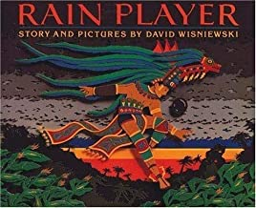 | Layout devices (Yr 6)  Commas, dashes, brackets to indicate Parenthesis (yr 5/6)  Relative clause (Yr 5/6)  Using the passive (Yr 6)  Modifying prepositional phrases (All)  Cohesion within paragraphs (Yr 5/6) | Instructional writing.  Descriptive writing.  Poster to advertise (persuade) | Instructions  Fact File
Autumn B (1 week mini project) | Christmas recipe writing.  Traditional Christmas cakes.  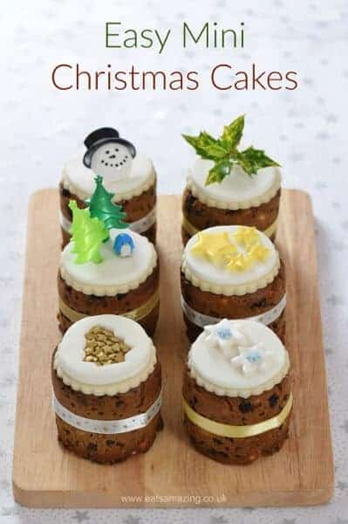 | Layout devices (Yr 6)  Plural and possessive s (All)  Apostrophes (All)  Hyphens (Yr 6) | Recipe (instructional).  Descriptive paragraph. | Recipe
Spring A | Cosmic by Frank Cottrell- Boyce  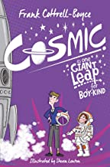 | Semi colons and dashes (Yr 6)  Formal and informal writing (All)  Commas to clarify meaning (Yr 5/6)  Paragraphs (Yr All)  Inverted commas (All)  Using the passive (Yr 6)  Cohesion across paragraphs (Yr 6) | Descriptive writing.  Using dialogue to progress action.  Character descriptions.  Use of layout devices.  Exciting sentence openers. | Narrative Chapter.  Itinerary.  Persuasive letter.
Spring B | I Talk Like a River  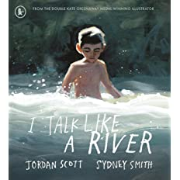 | Fronted adverbial (Y4)  Expanded noun phrases (Y4)  Similes and metaphors (Y4)  Commas to clarify meaning (Yr 5/6)  Paragraphs (Yr All)  Use devices to build cohesion (Y5)  Personification (Y6)  Children link ideas across paragraphs using a wider range of cohesive devices (Y6)  Use of passive voice (Y6) | Poetry writing  Using senses in descriptive writing  Describing character  Integrating speech | Haiku Poem to describe a river
Summer (whole term) | Secrets of a Sun King by Emma Carol  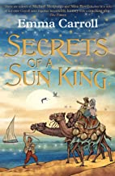 | Inverted commas (All)  Dashes, colons and semi-colons (Yr 6)  Parenthesis (Yr 5/6)  Apostrophes (All)  Plural and possessive s (All)  Paragraphs (All)  Formal and informal writing (Yr 6) | Newspaper report  Persuasive letter  Poem  Narrative | Narrative  Newspaper Report

