Early Help Offer
At Bromesberrow, we are motivated to provide Early Help to our children and families to promote support as soon as we can. It respects every family’s right to access information to manage their own lives successfully, whilst seeking support from appropriate sources. From time to time, we all go through situations which are difficult to cope with.
At these times, we need help and advice, but finding the right department or agency can be a minefield. The Early Help Offer gives parents a framework for asking for support. An assessment form may be completed, or signposting given, to provide parents and families with services who can help. This is only done with consent.
If you are ever in doubt, or feel like you need support to meet your individual needs please come and talk to us. We are here for you.
What is Early help?
Early help is providing support as soon as a problem emerges, at any point in a child’s life from the foundation years through to their teenage years. Early help can also prevent further problems arising; for example, if it is provided as part of a support plan where a child is returned home to their family from care, or in families where there are emerging parental mental health issues or drug misuse.
Any child may benefit from early help, however; we are particularly vigilant to the potential need for early help for a child who:
· is disabled and has specific additional needs
· has special educational needs (whether or not they have a statutory Education, Health and Care Plan)
· is a young carer
· is showing signs of being drawn in to anti-social or criminal behaviour, including gang involvement and association with organised crime groups
· is frequently missing/goes missing from care or from home
· is at risk of modern slavery, trafficking or exploitation
· is at risk of being radicalised or exploited
· is in a family circumstance presenting challenges for the child, such as drug and alcohol misuse, adult mental health issues and domestic abuse
· is misusing drugs or alcohol themselves
· has returned home to their family from care
· is a privately fostered child
The school works closely with local Family Hubs, Early Help services and partner agencies across both Herefordshire and Gloucestershire. With parental consent, referrals can be made to access support for parenting, emotional wellbeing, attendance, SEND needs, family relationships, financial wellbeing and other issues that may affect a child's development, wellbeing or educational progress.

For Parents
Support might be short or long term but will always be tailored to meet the needs of you and your family.
Areas of support might include:
- Support and advice during difficult periods i.e., illness, bereavement, financial worries, and domestic abuse.
- Support for parents in multi-agency meetings.
- Assistance in completing paperwork and forms e.g., Disability Living Allowance, housing, and benefits.
- Pre-loved uniform
- Support getting your child into school.
- Adult Education and Family Learning courses.
- Attendance monitoring with regular meetings. These aim to improve attendance and punctuality.
- Signposting to other services in the local area/community.
The list is not finite.

The help we offer is delivered by a wide range of professionals including;
- Education Psychologists
- Early Help Officers
- Early Help Social Workers
- Family Support Workers
- Child mental health specialists – Young Mind Matters
- In school Pastoral support assistant
- Winston’s Wish
- Speech and Language
- Herefordshire or Gloucestershire safeguarding team.
- Lego therapy
- Intervention support to reach My Plan targets.
As a school, we are aware of the locality of our families and wish to reassure you that we can seek the services required by talking to the relevant teams in either Gloucestershire or Herefordshire.
Early help offer Herefordshire –
The Children’s held and advice Team (CHAT) in Herefordshire has been developed to promote children and their families get the right help at the right time. CHAT sits alongside the Multiagency Safeguarding Hub and will be responsible for contacts which come into the local authority at level 3 or below and for contacts that MASH have assessed as not needing level 4 intervention. The advice team will proactively work with families and referrers to ensure the right support is offered this will include signposting, offering advice and guidance and facilitating the completion of an Early Help Assessment, where appropriate, with those families whose needs meet level 3 or high level 2 and who give their consent.
Contact information for CHAT: 01432 260261

Herefordshire have provided a list of services as part of their Early help strategy offer.
• Children Centre Services – support with parenting, speech and language
• Parenting Programmes – Triple P Standard, teen & Stepping Stones (for parents of children with additional needs).
• Young Carers Support Service 9
• Women’s Aid – programmes for children and young people – Helping hands and Crush
• Schools – Behaviour Support, support with attendance.
• Health: Health Visitor+, School Nurse service
• Mental Health services: CAMHS, Kooth, Counselling.
• CLIMB: Support for children & Young people at risk of Anti-Social Behaviour
• Finance & Debt: Christians Against Poverty
• Worklessness: Department for Work and Pensions
• Wearewithyou: Substance misuse.
• No Wrong Door: Youth drop in centre
• Bereavement services e.g. St Michael’s Hospice, Phoenix
Key partners include: Primary and Secondary Schools, Health Visitors, School Nurses, Midwives, General practitioners and other health practitioners, Mental Health partners CAMHS and Adult Services, Early Years providers, Police, Department of Work & Pensions, Housing Associations, Voluntary and Charitable organisations, HVOSS, Youth Offending Service and Probation
Early help offer Gloucestershire - The Gloucestershire Early Help and Targeted Support Service is made up of local teams of professionals who deliver practical advice and support to children, young people and their families.
Through –
• Children & Adolescent Mental Health (CAMHS)
• Community Social Worker/ Early Help Co-ordinator
• Early Years Service
• Education Inclusion Service
• Educational Psychology / Advisory Teaching Service
• Family Information Service
• Gloucestershire Domestic Abuse Support Service (GDASS)/ Street Gloucestershire
• Gloucestershire Healthy Living & Learning
• Gloucestershire Police – Schools Beat / Aston Project
• Multi Agency Safeguarding Hub
• Post 16 Education Team
• Restorative Practice Team
• School Nursing Team
• Young Minds Matter
• Youth Support Service
• Lets Talk Well
Gloucestershire believes that families are best supported by practitioners who are already working with them, as well as other organisations and services within their local community. These organisations include health services, schools, learning providers, councils, charities and voluntary groups, children and family centres, the police, housing providers and many others.
Early Help’ is an umbrella term that describes the work of many agencies engaged with children and families and focuses on how we can help people to do things for themselves and build on strengths within families. If we can get this right early on, at the right time, we get the opportunity to help people with areas of their life they may be struggling with, which sets people up for a better long-term future. It is also about providing support at any and every stage of a child’s life: pre-birth, during pregnancy, childhood and/or early adulthood.

Family Hubs
Herefordshire
Herefordshire Council is currently transitioning Children's Centres into Best Start Family Hubs, creating a county-wide network of support for children, young people and families. Family Hubs provide a single place where families can access advice, guidance and early intervention services from pregnancy through childhood and adolescence.
Services available through Herefordshire Family Hubs include:
- Family health and wellbeing services.
- Parenting programmes and support.
- Early Help family support and outreach.
- School readiness support.
- SEND support and signposting.
- Early education guidance.
- Support with childcare and nursery funding.
- Information, advice and referrals to specialist services.
- Employment and training signposting for parents and carers.
Families can also access support through the Children's Help and Advice Team (CHAT), which provides advice, guidance and access to appropriate Early Help services.
Contact: CHAT - 01432 260261 (Monday to Friday, 9am to 4.45pm)
Gloucestershire
Gloucestershire County Council's Family Hub model forms part of the county's Early Help Strategy and provides families with access to support at the earliest opportunity. Family Hubs bring together services and professionals to help children, young people and families access support within their local communities.
Family Hubs support families with:
- Parenting advice and programmes.
- Child development and school readiness.
- Emotional health and wellbeing.
- Family relationships.
- SEND advice and support.
- Youth support services.
- Access to targeted Early Help services where additional support is required.
- Signposting to health, education, employment and community services.
Where needs are more complex, families may be referred to the Families First service, which provides targeted support around parenting, attendance, behaviour, wellbeing, housing, finances and family resilience using a whole-family approach.

SEND
We are committed to ensuring that children and young people with Special Educational Needs and Disabilities (SEND) and their families receive the right support at the earliest opportunity.
The school works closely with families and a range of partner agencies across both Herefordshire and Gloucestershire to identify needs early, coordinate support and promote positive outcomes for children and young people. Early Help support is available from birth to age 18, and up to age 25 for young people with SEND.
Support may include:
- Advice and guidance for parents and carers.
- Early identification and assessment of additional needs.
- Support with attendance, behaviour and emotional wellbeing.
- Access to speech and language, health and therapy services where appropriate.
- Parenting support and family interventions.
- Support with transitions between educational settings.
- Signposting to community services and voluntary organisations.
- Access to Family Hubs and Early Help Services.
- SEND Information, Advice and Support Services (SENDIASS).
- Support through Education, Health and Care Needs Assessments (EHCNA) and Education, Health and Care Plans (EHCPs) where required.

Herefordshire SEND Support
Families can access the Herefordshire Local Offer, which provides information on services available for children and young people with SEND aged 0-25, including education, health, social care, short breaks, transport, preparing for adulthood and community support. Additional advice can be obtained through the Children's Help and Advice Team (CHAT) and local Family Hubs.

Gloucestershire SEND Support
Families can access the Gloucestershire Local Offer, which provides information about education, health and care services, SEND support in schools, therapy services, preparing for adulthood, short breaks and specialist support available across the county. Support can also be accessed through Family Hubs and Early Help services where appropriate.

How We Help
Where a child or young person with SEND would benefit from additional support, the school can work with families and partner agencies to complete an Early Help Assessment and coordinate a Team Around the Family approach. This ensures support is joined up, strengths-based and focused on achieving the best outcomes for the child and family.

Online Safety and Community Safety
The school recognises that children and young people can face risks both online and within their local communities. As part of our Early Help offer, we work with families and partner agencies to provide advice, support and early intervention where concerns arise. Herefordshire Council's Early Help services specifically provide support around keeping children safe online and in the community.
Support may include:
- Advice on safe use of social media, gaming platforms and online communication.
- Promoting positive digital citizenship and responsible online behaviour.
- Support for concerns relating to cyberbullying, online grooming and inappropriate online content.
- Guidance for parents and carers on managing children's online activity and privacy settings.
- Support where there are concerns about exploitation, including criminal exploitation, county lines activity or other forms of harm affecting children and young people.
- Advice and support relating to antisocial behaviour, youth violence and community safety concerns.
- Support to improve emotional wellbeing, resilience and decision-making skills.
- Signposting to specialist services, safeguarding partners and local community support when required.
Where concerns are identified, the school may work with families, Early Help services, Family Hubs, community organisations and safeguarding partners to ensure children and young people receive appropriate support at the earliest opportunity.

How can I access this service?
If you have some concerns a good starting point is to come and discuss your concerns with the DSL or SENCo at school, who can on your behalf, make a referral to the Gloucestershire Early Help and Targeted Support Team.
Our approach is to work closely with families. Before we can start to work with your family we need your consent. The work is confidential and you will be asked for permission for us to speak with other relevant professionals on your behalf.
Useful contact details:
Gloucestershire Family Information Service (FIS)
Advisors give impartial information on childcare, finances, parenting and education. FIS are a useful source of information for parents and professionals. They support families, children and young people aged 0-19 years of age (25 for young people with additional needs) and professionals working with these families. They can help link parents up with other organisations that might be able to help or provide the information themselves e.g. parents could ask them about holiday clubs for your children across Gloucestershire.
Contact the FIS by emailing:
facsglos@gloucestershire.gov.uk or telephone: (0800) 542 0202 or (01452) 427362. FIS also have a website which has a wealth of information to support many issues such as childcare and support for children with disabilities. https://www.glosfamiliesdirectory.org.uk/kb5/gloucs/glosfamilies/home.page
For information for Children and Young People with Special Education Needs and Disabilities (SEND) go to the SEN and Disability ‘Local Offer’ –
https://www.glosfamiliesdirectory.org.uk/kb5/gloucs/glosfamilies/family.page?familychannel=2_1
GSCB (Gloucestershire Safeguarding Children’s Partnership)
https://www.gloucestershire.gov.uk/gscp/
Important information for parents and professionals across Gloucestershire in relation to keeping children safe and avenues of support, including Early Help options.
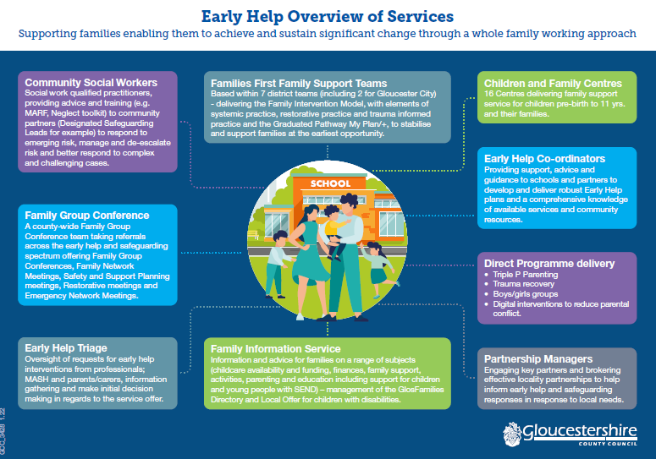
What should I do if I am worried or have a problem?
Please contact us if you have any problems affecting your child(ren). Usually raising awareness with the class teacher resolves many issues but we are all able to sign post to specific support when needed.
Any referral made requires your consent and the process is something you do alongside professionals.

- DSL or Deputy DSL – Miss Mison and Mrs Hankins
- Family support worker: Mrs Chesham
For more confidential issues including housing, finance and relationships.
- The class teacher will be your point of contact.
- The Special Educational Needs coordinator – Miss Oakes
To share information about behaviour, learning, medical issues, attendance, changes in family circumstances.

