# Intent

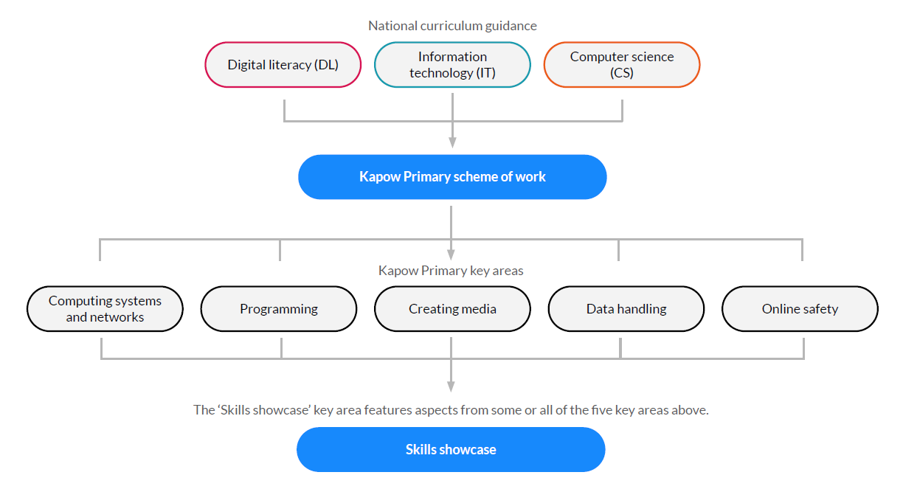At Bromesberrow St. Mary’s school our intent for Computing is (as for the whole curriculum) to build knowledge ‘cumulatively’, so that children build on their knowledge of the digital world, as they grow throughout the school, shining together and reaching for the stars. We teach children that technology can be used in a balanced way where it can enhance learning and enjoyment. Our core drivers for Computing are to ensure children develop:

* A good understanding of **computer science**, (how computer systems work) through algorithms, binary, networks, coding etc, so that children understand the basic principles of information and computation, how digital systems work and how to put this knowledge to use through programming.
* A good understanding of **information technology**, (the creation, manipulation and organisation of digital content), so that are able to present, analyse and evaluate data, expressing themselves through this using word processing, spreadsheets, graphing, databases, simulations, animation, blogging and presentation tools.
* Strong **digital literacy** skills, through e-safety, email and effective searching.

# Implementation

We use Kapow, a cloud based curriculum, to ensure that we prepare children for life in an ever changing digital world. We have chosen units from Kapow with our children and their cultural capital in mind, thereby carefully selecting units based on our mixed age classes and ensuring they get a variety of units which develop their digital literacy, information technology skills and computer science. We strive to develop their skills, understanding and confidence to learn and problem solve in a way that will enable them to confidently use existing technologies and technology of the future. To enhance this, we have included in our curriculum links to other subjects, showing the interconnectedness and application of computing as a cross curricular subject. To further supplement the digital literacy element we:

* Attend e-safety events through Gloucestershire Safeguarding Children's Board e.g. In the Net.
* Visit Skillzone, an amazing resource, which brings safeguarding to life in a safe and purpose built context.
* Plan for e-safety focussed assemblies
* Have e safety planned in as part of our PSHE curriculum.
* Take part in National e-safety week.
* Send out monthly internet safety newsletters regarding children’s online usage, the ages children should be accessing certain apps and also information about applying games limits.

Units in blue will be taught alongside other subjects and those in red are discrete computing units. This plan is to ensure that we have a clear coverage plan in place to enable all children to experience the breadth of the National Curriculum for computing and to support learning in other subjects with technology. Class One has a one year cycle, Class Two, a two year cycle and Class Three, a three year cycle.

We have adopted the STEM.org ‘I can Statements’ for each year group, to support staff and pupils to clearly understand what the learning expectation is for each year group, as well as show the breadth of the Computing Curriculum through the themes of:

* E-safety
* Programming
* Handling Data
* Multi-media
* Technology in our lives

We have ensured that our curriculum covers these areas (please see full progression below)

# Impact

In order for our Computing Curriculum to have had an impact, we would want to be able to see that children have a well-developed knowledge, skills and understanding, preparing them for the next stage of their education:

* Children who know how to keep themselves safe online
* Children who are confident and creative users of technology, being programmers, researchers, bloggers, data analysts etc… • Children who are able to express themselves through different digital means e.g. presenting their ideas and concepts. • Children who can use technology as a means to communicate e.g. through email and blogging

**Our rolling long-term plan:**

|  |  |  |  |
| --- | --- | --- | --- |
|  | **Class one reception / Y1** | **Class 2 Y2/Y3** | **Class 3 Y4/5/6** |
| **Autumn** | **(R and Y1 separate topics taught alongside each other)**  Mouse skills (Y1) using a computer (R) | **Cycle 1**  Word processing (Y2)  **Cycle 2**  Video trailers (iPads, Y3) | **Cycle 1**  Web design (Y4)  **Cycle 2**  Stop motion (Y5)  **Cycle 3**  Computational thinking (Y4) |
| **Spring** | Beebots (Y1) programming a bee bot (R) | **Cycle 1**  Emailing (Y3) and online safety (taught around safer internet day). (Y2)  **Cycle 2**  Stop motion (Y2) | **Cycle 1**  Microbit (Y5)  **Cycle 2**  Coding – scratch (Y4)  **Cycle 3**  Invent a product (Y6) |
| **Summer** | Digital imagery (Y1) computing systems and networks | **Cycle 1**  Scratch Jr (Y2)  **Cycle 2**  Comparison cards data bases –Microsoft office (Y3) | **Cycle 1**  Python (Y6)  **Cycle 2**  Search engine (Y5)  **Cycle 3**  Programming music (Y5) |