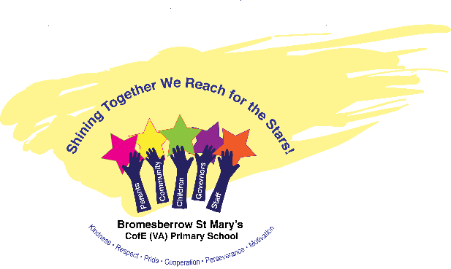

Bromesberrow St Mary’s C of E (VA) Primary School
and Preschool

British Values
Promoting fundamental British values at Bromesberrow St Mary’s C of E Primary School.

The Department for Education has published guidance on promoting British values in schools to ensure young people understand the importance of respect and leave school fully prepared for life in modern Britain. Schools have a duty to ‘actively promote’ the fundamental British values of democracy, the rule of law, individual liberty, and mutual respect and tolerance of those with different faiths and beliefs. At Bromesberrow we follow our Equal Opportunities policy which guarantees that there will be no discrimination against any individual or group, regardless of faith, ethnicity, gender, ability, sexuality, political or financial status, or similar.
• We promote ‘British Values’ through our spiritual, moral, social and cultural education which permeates through the school’s curriculum and underpins everything that we do.
• We support the development of the ‘whole child’ enabling them to become valuable and fully rounded members of society who treat others with respect and tolerance, regardless of background.
• We recognise that such development is most successful when those values and attitudes are promoted by all the staff and provide a model of behaviour for our pupils.
• The curriculum offers broad and balanced opportunities.
British Values have been identified as:
Democracy: The ability to understand and communicate are the most important areas of learning. We ensure that pupils are given a ‘voice’ to communicate. This ‘voice’ could be using words, objects, photographs, pictures, symbols or other means. We empower our pupils by giving them opportunities to make choices about things which are important to them. By valuing each ‘voice’ and by listening and responding to that voice we demonstrate that we support democracy and liberty. We ensure all pupils within the school have a voice that is listened to and demonstrate how democracy works by actively promoting democratic processes such as the voting of school council members and Friend Helpers for the playground.
Rule of Law: Pupils are helped to learn to manage their behaviour and take responsibility for their actions. We involve pupils in setting rules of behaviour e.g. behaviour in their classroom and Worship; helping pupils to make decisions and choices that are acceptable to the school community and society at large. We support children in understanding that everyone has a responsibility and that there are consequences when rules are broken. They recognise that whilst we have rules at school, other rules and laws exist in the country for the same reasons. Staff are committed to providing a consistent and safe environment within the setting. We can help some pupils to understand the connection between actions and consequences. This type of environment enables pupils to feel safe and secure; this in turn, promotes the optimum conditions for learning to take place.
Individual Liberty: Pupils are encouraged to become good and valued citizens. We do this by supporting each pupil to become as independent as possible and encourage them to help and support each other (3B4Me). We endeavour to demonstrate that everyone has rights; this includes the right to say 'Yes' or 'No' to ideas or activities. Some pupils will be able to take responsibility for particular roles and to understand that with certain rights comes a level of responsibility such as our Friendship helpers on the playground.
We then show our support to others by participating in charitable events such as Children In Need and Red Nose Day along with supporting the local foodbank. We believe that encouraging a caring and helpful environment and being independent can boost and nurture a healthy self-esteem.
Mutual Respect: Respect is an underpinning core value within our school, whereby we encourage children to treat others how they would want to be treated and working together positively. We promote each pupil’s inclusion in activities, settings and locations that are appropriate to them individually to meet their needs. Within school, pupils work with a range of people and interactions with others which are always commented on as being positive. We follow an enquiry based curriculum and meets the individual needs of our pupils. We believe it is important to facilitate opportunities to be part of the community as the pupils, families and staff have much to offer in the development of community cohesion.
Tolerance of different faiths and beliefs: We are part of a school and local community where each person is respected and valued equally without regard to ability, gender, faith, heritage or race. Cultural appreciation and development forms part of our curriculum. We place great emphasis on providing encounters and participation in events and celebrations to broaden all pupils’ experiences and awareness of others. Through whole school Collective Worship we share stories, images, events, music and expectations that promote the values expressed. ‘Collective worship’ recognises that those attending may have a wide range of faiths, or none. It is, however, in line with regulation and is “wholly or mainly of a broadly Christian character’’ as we are a Church of England school.

