Early Help Offer
At Bromesberrow, we are motivated to provide Early Help to our children and families to promote support as soon as we can. It respects every family’s right to access information to manage their own lives successfully, whilst seeking support from appropriate sources. From time to time, we all go through situations which are difficult to cope with.
At these times, we need help and advice, but finding the right department or agency can be a minefield. The Early Help Offer gives parents a framework for asking for support. An assessment form may be completed, or signposting given, to provide parents and families with services who can help. This is only done with consent.
If you are ever in doubt, or feel like you need support to meet your individual needs please come and talk to us. We are here for you.
What is Early help?
Early help is providing support as soon as a problem emerges, at any point in a child’s life from the foundation years through to their teenage years. Early help can also prevent further problems arising; for example, if it is provided as part of a support plan where a child is returned home to their family from care, or in families where there are emerging parental mental health issues or drug misuse. – Working Together to safeguard children July 2018.
For Parents
Support might be short or long term but will always be tailored to meet the needs of you and your family.
Areas of support might include
- Support and advice during difficult periods i.e., illness, bereavement, financial worries, and domestic abuse.
- Support for parents in multi-agency meetings.
- Assistance in completing paperwork and forms e.g., Disability Living Allowance, housing, and benefits.
- Pre-loved uniform
- Support getting your child into school.
- Adult Education and Family Learning courses.
- Attendance monitoring with regular meetings. These aim to improve attendance and punctuality.
- Signposting to other services in the local area/community.
The list is not finite.

The help we offer is delivered by a wide range of professionals including;
- Education Psychologists
- Early Help Officers
- Early Help Social Workers
- Family Support Workers
- Child mental health specialists – Young Mind Matters (Trailblazers)
- In school Pastoral support assistant
- Winston’s Wish
- Speech and Language
- Herefordshire or Gloucestershire safeguarding team.
- Lego therapy
- Intervention support to reach My Plan targets.
As a school, we are aware of the locality of our families and wish to reassure you that we can seek the services required by talking to the relevant teams in either Gloucestershire or Herefordshire.
Early help offer Herefordshire –
The Early Help Hub in Herefordshire has been developed to promote children and their families get the right help at the right time. The Early Help Hub sits alongside the Multiagency Safeguarding Hub and will be responsible for contacts which come into the local authority at level 3 or below and for contacts that MASH have assessed as not needing level 4 intervention. The Early Help Hub will proactively work with families and referrers to ensure the right support is offered this will include signposting, offering advice and guidance and facilitating the completion of an Early Help Assessment, where appropriate, with those families whose needs meet level 3 or high level 2 and who give their consent.
Herefordshire have provided a list of services as part of their Early help strategy offer.
• Children Centre Services – support with parenting, speech and language
• Parenting Programmes – Solihull, Triple P Standard, teen & Stepping Stones (for parents of children with additional needs).
• Young Carers Support Service 9
• Women’s Aid – programmes for children and young people – Helping hands and Crush
• Schools – Behaviour Support, support with attendance.
• Health: Health Visitor+, School Nurse service
• Mental Health services: CAMHS, Kooth, Counselling.
• CLIMB: Support for children & Young people at risk of Anti-Social Behaviour
• Finance & Debt: Christians Against Poverty
• Worklessness: Department for Work and Pensions
• Wearewithyou: Substance misuse.
• No Wrong Door: Youth drop in centre
• Bereavement services e.g. St Michael’s Hospice, Phoenix
Key partners include: Primary and Secondary Schools, Health Visitors, School Nurses, Midwives, General practitioners and other health practitioners, Mental Health partners CAMHS and Adult Services, Early Years providers, Police, Department of Work & Pensions, Housing Associations, Voluntary and Charitable organisations, HVOSS, Youth Offending Service and Probation
Early help offer Gloucestershire - The Gloucestershire Early Help and Targeted Support Service is made up of local teams of professionals who deliver practical advice and support to children, young people and their families.

How can I access this service?
If you have some concerns a good starting point is to come and discuss your concerns with the CoHeadteachers, who can on your behalf, make a referral to the Gloucestershire Early Help and Targeted Support Team.
Our approach is to work closely with families. Before we can start to work with your family we need your consent. The work is confidential and you will be asked for permission for us to speak with other relevant professionals on your behalf.
Useful contact details:
Gloucestershire Family Information Service (FIS)
Advisors give impartial information on childcare, finances, parenting and education. FIS are a useful source of information for parents and professionals. They support families, children and young people aged 0-19 years of age (25 for young people with additional needs) and professionals working with these families. They can help link parents up with other organisations that might be able to help or provide the information themselves e.g. parents could ask them about holiday clubs for your children across Gloucestershire.
Contact the FIS by emailing:
familyinfo@gloucestershire.gov.uk or telephone: (0800) 542 0202 or (01452) 427362. FIS also have a website which has a wealth of information to support many issues such as childcare and support for children with disabilities. www.glosfamilies.org
For information for Children and Young People with Special Education Needs and Disabilities (SEND) go to the SEN and Disability ‘Local Offer’ - www.glosfamilies.org.uk/localoffer
GSCB (Gloucestershire Safeguarding Children’s Board)
http://www.gscb.or.uk
Important information for parents and professionals across Gloucestershire in relation to keeping children safe and avenues of support, including Early Help options.
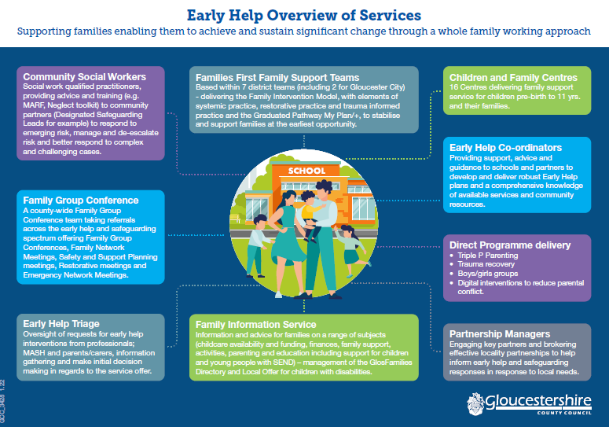
What should I do if I am worried or have a problem?
Please contact us if you have any problems affecting your child(ren). Usually raising awareness with the class teacher resolves many issues but we are all able to sign post to specific support when needed.
Any referral made requires your consent and the process is something you do alongside professionals.
For more confidential issues including housing, finance and relationships.
- Pastoral Support Assistant – Mrs Chesham
- CoHeadteachers – Miss Mison and Mrs Hankins
- The class teacher will be your point of contact.
- The Special Educational Needs coordinator – Mrs Hankins
To share information about behaviour, learning, medical issues, attendance, changes in family circumstances.

