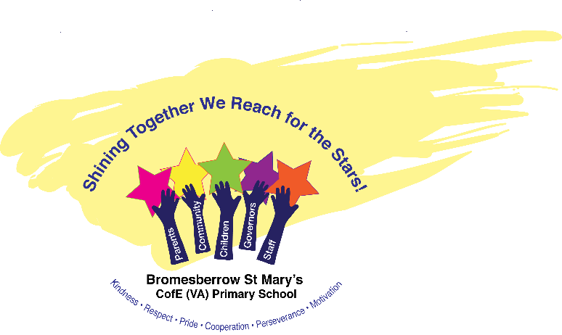

Bromesberrow St. Mary’s Church of England Primary School

Remote Education Policy

April 2025

Review April 2026

# Remote education provision: information for parents

This information is intended to provide clarity and transparency to pupils and parents or carers about what to expect from remote education where national or local restrictions require entire cohorts (or bubbles) to remain at home.

For details of what to expect where individual pupils are self-isolating, please see the final section of this page.

## The remote curriculum: what is taught to pupils at home

A pupil’s first day or two of being educated remotely might look different from our standard approach, while we take all necessary actions to prepare for a longer period of remote teaching.

### What should my child expect from immediate remote education in the first day or two of pupils being sent home?

In the first instance of sending pupils home, we would organise:

* Set remote learning using Oak Academy and Kapow resources (as well as other online platforms e.g. TTRockstars and Numbots
* Workbooks (set physical work to complete)

### Following the first few days of remote education, will my child be taught broadly the same curriculum as they would if they were in school?

* We teach the same curriculum remotely as we do in school wherever possible and appropriate. However, we have needed to make some adaptations in some subjects. For example, in music we may direct to online music sessions/videos to listen and respond to with a corresponding activity. This is different to our music specialist who comes in the teach music in person and with a more practical element. We would offer an online video/virtual experience to ensure access to direct teaching.

## Remote teaching and study time each day

### How long can I expect work set by the school to take my child each day?

We expect that remote education (including remote teaching and independent work) will take pupils broadly the following number of hours each day:

|  |  |
| --- | --- |
| Key Stage 1 | 3-4 hours |
| Key Stage 2 | 4 hours |

## Accessing remote education

### How will my child access any online remote education you are providing?

Microsoft Teams- live teaching element

Via email for hard copies and physical packs where required to support.

### If my child does not have digital or online access at home, how will you support them to access remote education?

We recognise that some pupils may not have suitable online access at home. We take the following approaches to support those pupils to access remote education:

* We will support by:
* Lending laptops or ipads
* Sourcing routers if required to enable internet access
* Printed packs will be available to collect from school office
* Work returned to school office

### How will my child be taught remotely?

We use a combination of the following approaches to teach pupils remotely:

* live teaching (online lessons)
* recorded teaching (e.g. Oak National Academy lessons, video/audio recordings made by teachers)
* printed paper packs produced by teachers (e.g. workbooks, worksheets)
* textbooks and reading books pupils have at home
* long-term project work and/or internet research activities

## Engagement and feedback

### What are your expectations for my child’s engagement and the support that we as parents and carers should provide at home?

* We expect parents to ensure their child is supported and provided with a quiet space to focus to attend live sessions
* Parents to support with routines to ensure child can learn and focus on remote learning.

### How will you check whether my child is engaging with their work and how will I be informed if there are concerns?

In this section, please set out briefly:

* Check in will happen everyday. Expectation will be that your child attends online sessions and completes work set. If this isn’t happening then your child’s teacher would email or telephone to work to support this process. Work to be emailed.

### How will you assess my child’s work and progress?

Feedback can take many forms and may not always mean extensive written comments for individual children. For example, whole-class feedback or quizzes marked automatically via digital platforms are also valid and effective methods, amongst many others. Our approach to feeding back on pupil work is as follows:

* Feedback will take place throughout the live session through quizzing, dialogue and feedback.
* Feedback will also be written as appropriate.

## Additional support for pupils with particular needs

### How will you work with me to help my child who needs additional support from adults at home to access remote education?

We recognise that some pupils, for example some pupils with special educational needs and disabilities (SEND), may not be able to access remote education without support from adults at home. We acknowledge the difficulties this may place on families, and we will work with parents and carers to support those pupils in the following ways:

* We will support families with adaptations and work which is appropriate and differentiated to their needs.