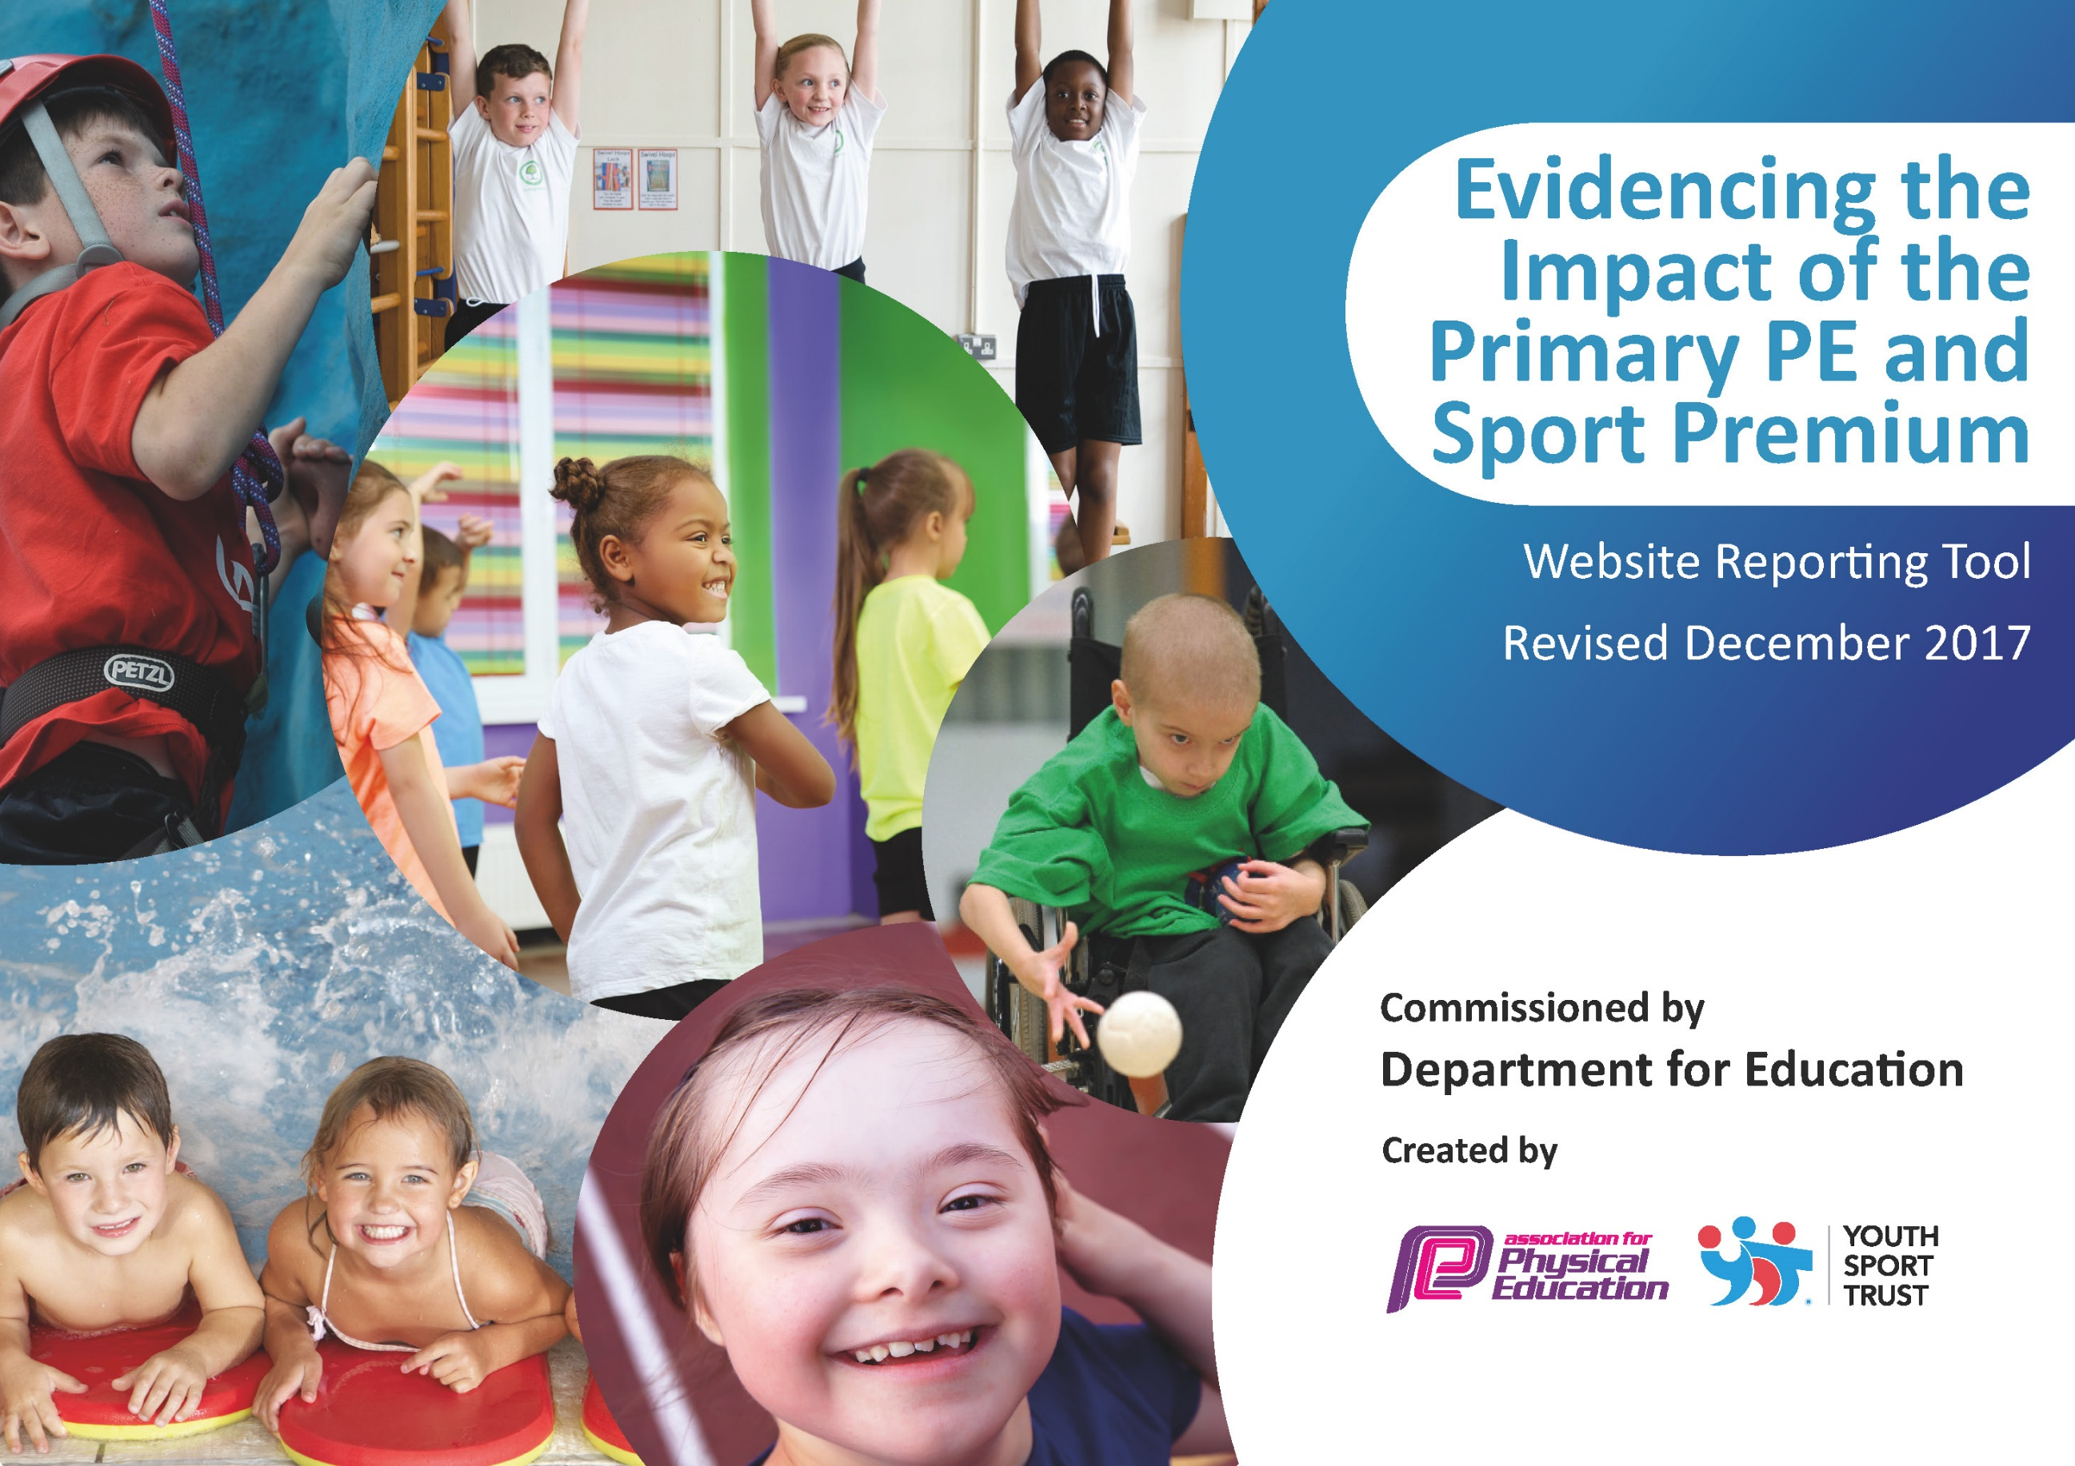

Schools must use the funding to make additional and sustainable improvements to the quality of PE and sport they offer. This means that you should use the Primary PE and Sport Premium to:

- develop or add to the PE and sport activities that your school already offers
- build capacity and capability within the school to ensure that improvements made now will benefit pupils joining the school in future years

Please visit gov.uk for the revised DfE guidance including the 5 key indicators across which schools should demonstrate an improvement. This document will help you to review your provision and to report your spend. DfE encourages schools to use this template as an effective way of meeting the reporting requirements of the Primary PE and Sport Premium.

We recommend you start by reflecting on the impact of current provision and reviewing the previous spend.
Under the Ofsted Schools Inspection Framework, inspectors will assess how effectively leaders use
the Primary PE and Sport Premium and measure its impact on outcomes for pupils, and how effectively governors hold them to account
for this.

Schools are required to publish details of how they spend this funding as well as on the impact it has on pupils’ PE
and sport participation and attainment.
We recommend regularly updating the table and
publishing it on your website as evidence
of your ongoing review into how you are using the money
to secure maximum, sustainable impact. To see an example of how to complete the table please click HERE.

Bromesberrow St Mary’s Primary School Swimming data 2021-2022

Meeting national curriculum requirements for swimming and water safety | Please complete all of the below*:
What percentage of your current Year 6 cohort swim competently, confidently and proficiently over a distance of at least 25 meters? | 70 %
What percentage of your current Year 6 cohort use a range of strokes effectively [for example, front crawl, backstroke and breaststroke]? | 70 %
What percentage of your current Year 6 cohort perform safe self-rescue in different water-based situations? | 70 %
Schools can choose to use the Primary PE and Sport Premium to provide additional provision for swimming but this must be for activity over and above the national curriculum requirements. Have you used it in this way? | No

Bromesberrow St Mary’s Primary School Sports Funding 2021-2022

Academic Year: 2022/23 | Total fund allocated: £16580 | Date Updated: September 2022
Key indicator 1: The engagement of all pupils in regular physical activity – Chief Medical Officer guidelines recommend that primary school children undertake at least 30 minutes of physical activity a day in school
School focus with clarity on intended impact on pupils: | Actions to achieve: | Funding allocated: | Evidence and impact: | Sustainability and suggested next steps:
Build on our “Active Playgrounds” initiative – more children taking part in activities at break and lunchtimes.  A range of playground equipment to entice children to be more physically active. This includes clear playground markings to support the play of children alongside being purposeful in PE lessons.  Increase the number of children attending after school clubs in a variety of sports and healthy eating.  Curriculum designed carefully to provide children with a breadth of sporting opportunities throughout the whole of their schooling. - Further improvement required in line with guidance. Intent, implementation and impact.  Swimming lessons for pupils who have not been able to meet the national curriculum requirements for swimming and water safety - after the delivery of core swimming and water safety lessons. | All classes – ensure Trim Trail and Adventure Playground are timetabled for all classes to use.  Class 1, 2 and 3 timetable of activities on notice board in corridor and on shed. This details the activities each class can access each day at break and lunchtimes.  Midday supervisor to initiate playground games, challenges –Engage vulnerable groups, children to be motivated and to use. Inspiring even the youngest of children to partake in physical activity.  PE lead in liaison with School Council to decide on types of equipment/playground markings.  Research different playgrounds – visits to other schools, online etc.  Mud kitchen area to be developed on the large playground to provide children with the opportunity to refine their growth and fine motor schools during playtimes.  Gloucestershire Cricket club (class 1 and 2 1 hour lessons for 6 weeks. Ks 2 club 6 weeks)  Dance club  Non active children identified through survey and opportunities to do activity they enjoy explored.  Food Teach club to be ran for all children to learn about and practice healthy eating in more depth.  Link with Bubbles Nursey established, supporting our most vulnerable children to access physical activity.  Lend/share school sports equipment to increase range of what is on offer.  Sporting afternoons developed in school, led by PE Led.  Curriculum writing and whole school coverage plan shared with staff.  Feed PE into other areas of the curriculum through ‘Active RE’.  Forest School to be utilized to support physical activity in other ways and develop fine and gross motor skills. CPD provided to staff through Forest School leader running these sessions.  Ensure the curriculum requirement is met for those children who have had reduced experiences when swimming so that they swim 25m or more, use a range of strokes effectively, perform self-rescue in different water based situations. | £1140  £1500  £200  £280  £300  £150  £500/ £1400  £810 | Each class will access to Trim Trail or activities each day on a rota.  A happy playground is created because no one group of children dominates the playground.  Children’s stamina levels to have visibly increased during PE sessions.  Fewer incidents of children falling out.  Children exhibiting purposeful play with little adult intervention to resolve disputes.  Children to be more involves and motivated to use playground areas to increase children’s movement.  Children to work collaboratively. Growth and fine motor skills to be improved. Children to have a greater enjoyment for physical activity during playtimes.  Vulnerable children attending extra opportunities to get active outside of the school day.  Children who are excited about activity, enjoyment levels increased – pupil voice.  All children engaged in Sports Afternoons with non-active children focused as leaders/ambassadors in sport.  All pupils will be involved in 15 minutes extra activity per day.  Children inspired by positive role models.  Children are able to talk about a range of sports they have enjoyed. Increased number of children attending extra activities around sports.  WIDER IMPACT ASSESSMENT:  - Greater participation in all PE lessons  - Continue to maintain improvement of SAT’s results  - Improved attitudes which lead to learning and behaviour. | Permanent structure so it is embedded into the school day.  Next steps – Pupil survey to understand interests and motivations.  Look how we can use raised money through PTA to enhance play equipment.  Staff to effectively model the use of the mud kitchen.  Aim to increase numbers in clubs and outside school through further advertising and purchase/hire of equipment.  Aim for children to understand the importance of nutrition and a healthy balanced diet and how this impacts physical health.  Introduce further pupil survey to identify popular activities and future sporting activities to target increased participation.  Aspiration in sport and self- achievement increased.  Link to fund raising and activities led and organized by School Council. Raising money and awareness of charities through sport.  Used sporting achievements by staff and children as incentive and motivation for all of the school community.
Key indicator 2: The profile of PE and sport being raised across the school as a tool for whole school improvement
School focus with clarity on intended impact on pupils: | Actions to achieve: | Funding allocated: | Evidence and impact: | Sustainability and suggested next steps:
Every week children across school have opportunity to share their out of school sporting achievements with the community through celebration assembly.  Ensure staff, Governors parents and the wider school community are aware of PE and sporting events activities that are taking place.  Friday celebration assemblies to highlight sporting achievements and PE success in order to highlight the importance of PE and to encourage all pupils to aspire to be involved.  KS1 and KS2 to be involved in as many sporting events as possible with local schools. This will include: football, netball, rounders, table tennis, athletics and multi sports. Ledbury Rugby tournament.  A positive impact on the children’s wellbeing and using P.E to support our PSHE curriculum to recognise the links between a healthy mind and a healthy body. | Encourage children who belong to clubs outside school to share what their experiences are, bring in photos, medals and certificates.  Promote any events on school website and Facebook page.  Sports results to be celebrated in Friday Assemblies, match reports to be written and read by the children where appropriate and published on school website.  Mini bus transportation available to get children to such events across the year.  Event shelters available to ensure weather does not become an impact of safe participation.  Trained members of staff to lead and deliver PSHE curriculum using PE to support and be used as a CPD opportunity for staff.  Staff member to run and plan Lego therapy for children’s wellbeing and fine motor skills. | £150  £500  £500  £1000  £800 | Children will be knowledgeable about these and have an opportunity to contribute to “what’s on offer”  PE profile will be raised in school.  Children will feel recognized for their sporting successes.  Will use feedback both formal and informal from children and parents to gauge impact. Ensure geography of our school does not impact participation.  This will boost childrens passion and motivation for sporting activities within school and create a ‘TEAM’ ethos.  Greater increase of whole school participation in high quality PE lessons, access to larger range of sports clubs and sports competitions. High quality planning and CPD for all staff.  All children to have taken part in an assembly, received a celebration certificate and have encouraged parents to attend sports events.  Children will have a more positive attitude towards themselves and others through a curriculum that is broad and progressive in terms of the mental and physical needs.  Pupil voice | Opening the doors further between school and home through  Sport – recognizing the importance of outside of the classroom.  Increase profile of PE, healthy lifestyles and activity as a basis for a healthy life.  Governors to oversee the raised profile of PE and sport and to ensure the funding is to be spent appropriately. Sue.T. PE Governor,  Increase in parental engagement impacting on whole curriculum to raise achievement.  Further links to JMHS, increasing our access to different facilities.  Aiding transition for Y6 to High School.  Staff will be trained to run these sessions on their own over time.

Key indicator 3: Increased confidence, knowledge and skills of all staff in teaching PE and sport

School focus with clarity on intended  impact on pupils: | Actions to achieve: | Funding  allocated: | Evidence and impact: | Sustainability and suggested  next steps:
All teachers to continue to benefit from working alongside PE and PSHE Lead to increase their subject knowledge and further improve their delivery of PE.  To build role of PE Ambassador.  Support provided to Teaching Partners to ensure their knowledge in a healthy, active lifestyle is being transferred during their roles as sport  Worcester Warriors rugby club led PE sessions as CPD for staff to improve their skills and knowledge in rugby.  Gloucestershire Cricket coaches led PE sessions as CPD to staff to improve their skills and knowledge in cricket. | All teachers are timetabled to work alongside the specialist PE staff throughout the year. They will experience the teaching of different activity areas.  Staff to be trained in outdoor learning as a tool to further enhance the curriculum and physical opportunities for children.  Relevant CPD provide to support the building of the curriculum and knowing how to support staff.  Identify courses for all staff and set up baseline to measure impact over time.  Staff to feel more confident in the delivery of a range of sports. | £1000  £500  £100  £300 | Will use feedback from teaching staff about their levels of confidence to deliver PE.  Use lesson observations.  Children’s attainment in PE to increase further – 98% meeting end of key stage targets.  All staff to contribute to children’s assessment in PE.  Better subject knowledge across whole school.  Improved outcomes for all pupils.  Teaching and learning of rugby to have improved. Observations, teacher feedback and pupil voice. | Phase Leads to increase qualifications in leading quality PE and sport throughout the school, conducting observations and analyzing data. TDP link with training within subject leader network.
Key indicator 4: Broader experience of a range of sports and activities offered to all pupils
School focus with clarity on intended  impact on pupils: | Actions to achieve: | Funding  allocated: | Evidence and impact: | Sustainability and suggested  next steps:
To purchase a complete set of current PE equipment for future use and in addition purchase a broader range of sport equipment in order to offer a greater variety of sports to all of the children.  Class 3 children able to access bell boating day trip and competition to further enthuse a love of alternative sports. Provide by competitive sports person.  Years 4-6 have increased opportunity to access outdoor, team building centers to support interest in range of sports available e.g. paintballing, zip wire, climbing walls | Increase further sports and PE attendance of non-active children by a further 10%  PE lead to liaise and organize with local bell boating group in Tewkesbury.  Children to not be disadvantaged by the costs of such activities therefore money is used to subsidies such events e.g. Oakerwood, Viney Hill | £2700  £150  £1000 | To have a greater variety of balance, skills, fitness and gymnastic equipment available to all of the children.  Greater increase in participation of a range of sporting opportunities.  Team work | A clear audit on PE equipment to be completed and used to support the enhancement of equipment.  Children to problem solve and work together in a team to build confidence and resilience supporting classroom ethos and their growth as individuals to feel ready to go to High School.
Key indicator 5: Increased participation in competitive sport
School focus with clarity on intended  impact on pupils: | Actions to achieve: | Funding  allocated: | Evidence and impact: | Sustainability and suggested  next steps:
Provide opportunities for pupils to participate in competitive tournaments covering a broad range of sports.  Link with other schools to create more inter team competitions.  Develop more intra team competitions for the school “castles” to compete against each other. | Liaise with both JMHS and TDP to involve as many children as possible in competitions and tournaments.  Arrange fixtures in a variety of different activities  Ensure our playground is adequately marked to ensure we can play competitive games correctly. | £100 for transportation  £600 | Children in our small school setting are able to be part of extended teams to compete.  Develop competitive sportsmanship which impacts on curriculum.  Increased motivation and perseverance in learning  Team work. | Transition to be a priority to enable our children to be confident and high school ready.

