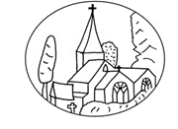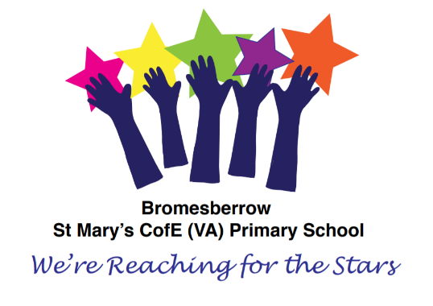****



**Bromesberrow St Mary’s C of E (VA) Primary School and Preschool**

**Calculation Policy**

**February 2023**

**Review: 2024**

At Bromesberrow St Mary’s Primary school, we believe that all children are capable of doing and understanding mathematics with the right teaching and support. Through building a ‘can do’ attitude, with high-quality teaching, resources and effort; all children can enjoy and achieve within maths. Throughout our school, we are driven to provide children with the key concepts and building blocks to be brilliant and aspirational mathematicians.

At Bromesberrow, Mastery is the ‘knowing’ and ‘understanding’ of key concepts combined; it is not just about being able to answer questions quickly and accurately. Mastery is knowing why and how and being able to select the most appropriate methods for them. All of our children are provided with these examples during their teacher input whilst following a sequence of **concrete, pictorial and abstract questioning and learning** (outlined within this calculation policy), which are appropriate to their learning need and to enhance their fluency, reasoning and problem solving learning. We aim to see our children being able to use their knowledge appropriately, flexibly and creatively; applying their knowledge to new and unfamiliar situations.

Below is the schools calculation policy, including examples of concrete, pictorial and abstract questions.

|  |  |  |  |
| --- | --- | --- | --- |
| **Objective and strategies**  **Addition.** | **Concrete** | **Pictorial** | **Abstract** |
| Combining two parts to make a whole: part-whole model.  Reception/ year 1 and year 2. | Use cubes to add two numbers together as a group or a bar. | Use pictures to add two numbers together in a group or in a bar. | 4 + 3 = 7    10 = 6 + 4  Use the part-part whole diagram as shown above to move into the abstract. |
| Starting at the larger number and counting on.  Year 1 and Year 2. |  |  |  |
| Regrouping to make 10.  Year 2. | Use the bigger number and then the smaller number to make 10.  e.g. recognise number bonds to 10 to support. |  |  |
| Adding three single digit numbers.  Year 1 and Year 2. |  | + + =  Add together three groups of objects. Draw a picture to recombine the groups to make 10 then add on. | 4 + 6 + 2 =  4 + 6 = 10  10 + 2 = 12    10  3  3  4  Combine the two numbers to make 10 and count on the final digit. |
| Adding two 2 digit numbers mentally with resources to support. Year 2 and Year 3. | 46 + 27 = |  |  |
| Column method – no regrouping  Year 3/4/5/6  Using same methods with numbers of different digits depending on year group objective. |  |  |  |
| Column method – regrouping.  Year 3/4/5/6  Using same methods with numbers of different digits depending on year group objective. | Add up the rest of the columns, exchanging the 10 counters from one column to the next place value column until every column has been added. |  | As the children move on introduce decimals with the same number of decimal places and different. Money can be used here. |

|  |  |  |  |
| --- | --- | --- | --- |
| **Objective and Strategies.**  **Subtraction.** | **Concrete** | **Pictorial** | **Abstract** |
| Taking away ones.  Reception/ Year 1 |  |  |  |
| Counting back.  Year 1 and Year 2. |  |  |  |
| Counting on to find the difference.  Year 1 and Year 2. |  |  |  |
| Part part whole model.  Year 1 and Year 2. |  |  | 10 -5 = |
| Make 10  Year 2 | Make 14 on the ten frame. Take away the four first to make 10 and then takeaway one more so you have taken away 5. You are left with the answer of 9. |  |  |
| Subtracting two 2 digit numbers no regrouping.  Year 2 |  |  |  |
| Subtracting two 2-digit number with regrouping.  Year 2 and Year 3. |  |  |  |
| Column method without regrouping  Year 3/4/5/6  Using same methods with numbers of different digits depending on year group objective. |  |  |  |
| Column method with regrouping.  Year 3/4/5/6  Using same methods with numbers of different digits depending on year group objective. |  |  |  |
| **Objective and strategies**  **Multiplication** | **Concrete** | **Pictorial** | **Abstract** |
| Doubling  Reception/ Year 1 |  |  |  |
| Counting in multiples  Reception/ Year 1 |  |  |  |
| Repeated addition  Year 1/ Year 2 |  |  |  |
| Arrays – showing commutative multiplication  Year 2/ Year 3/ Year 4 |  |  |  |
| Grid Method  Year 3/ Year 4 |  |  |  |
| Column Multiplication  Year 4/ Year 5/ Year 6 |  |  |  |
| **Objective and Strategies.**  **Division** | **Concrete** | **Pictorial** | **Abstract** |
| Equal groups  Reception/ Year 1 |  | Possible activities and opportunities:   * During snack time – give one child 2 banans, another 2 apples – ask ‘is this fair?’ Discuss. * During lay – rewards for ‘sharing fairly’ E.g. ‘we have got 4 toy cars and 2 children, what should we do?’ extend by questioning – what if there were 3 children?   2. Sorting fairly (link to Venn diagrams)  Possible activities:   * Use manipulatives such as dinosaurs, beas etc to sort – develop consideration of colour, suze type of toy etc. * Have hoops and chaacters in charge of each hoop e.g. two dinosaurs – each dinosaur needs the same as the other in their hoop – begin with an even number of the same coloured unifix cubes – then introdice another set of a different colour – how are we going to make sure the dinosaurs still have equal sets of objects in terms of colour and number? Extend by introducing a wider range of colours, numbers andd types of objects. * Sorting the bean bafs during P.E. so that it is fair for each group. |  |
| Halving  Reception/ Year 1 |  |  |  |
| Sharing objects into groups.  Year 1/ Year 2 |  |  |  |
| Division as grouping  Year 2 |  |  |  |
| Division within arrays  Year 2 |  |  |  |
| Division with a remainder  Year 2/ Year 3 |  |  |  |
| Short division  Year 4/ Year 5/ Year 6 |  |  |  |
| Long division  Year 5/ Year 6 |  |  |