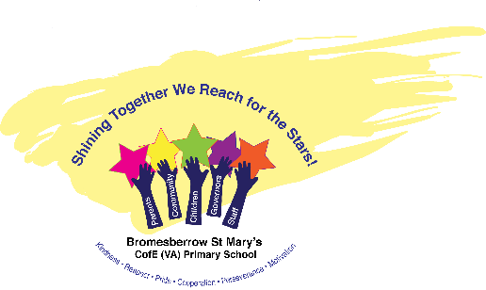

**Guided Reading Quality Text Planner**

We use the DERIC Approach developed by Rhoda Wilson to plan and teach reading explicitly at Bromesberrow. All of our texts are carefully chosen and planned in advance, from Early Years through to Year 6, to ensure that the children’s reading diet is broad and balanced. The texts chosen and the level of questioning is progressive throughout the school, so that learning is cumulative.

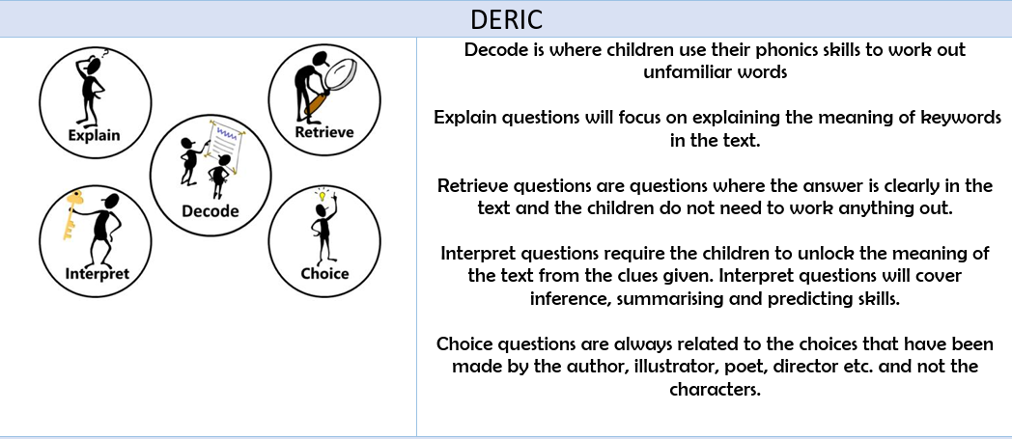

|  |  |  |
| --- | --- | --- |
| **Reception** | | |
| **Autumn A** | **Spring A** | **Summer A** |
| **Reception-** *Weekly focused text (story telling) with DERIC questions planned prior to reading*  **Non Fiction texts:**  **Animal Homes by Libby Waldon**  https://images-na.ssl-images-amazon.com/images/I/516TsYasxfL._SX441_BO1,204,203,200_.jpg  **Tree by Britta Treckentrup**  Tree: Seasons Come, Seasons Go by [Patricia Hegarty, Britta Teckentrup]  **Prickly Hedgehogs by Jane Mcguiness**  https://images-na.ssl-images-amazon.com/images/I/51hDJBf4ngL._SX455_BO1,204,203,200_.jpg  **Fiction texts:**  **Dear Zoo by Rod Campbell**    **The Very Hungry Caterpillar by Eric Carle**    **The Tiger who came to Tea by Judith Kerr**    **Stickman by Julia Donaldson**  https://images-na.ssl-images-amazon.com/images/I/51O5VYoo2pL._SX395_BO1,204,203,200_.jpg  **Lost and Found by Oliver Jeffers**    **The Three Billy Goat’s Gruff**  https://www.theworks.co.uk/dw/image/v2/BDXF_PRD/on/demandware.static/-/Sites-master-catalog-tws-uk/default/dw50bbfe50/9781409312345_Z.jpg?sw=400&sh=400&sm=fit  **Peepo by Janet and Alan Ahlberg**  Peepo! (Storytime Giants) by [Allan Ahlberg, Janet Ahlberg]  **The Snowman by Raymond Biggs**    **The Nutcracker**  **Twelve Days of Christmas by Britta Teckentrup**  https://images-na.ssl-images-amazon.com/images/I/51L4HIh3dTL._SX407_BO1,204,203,200_.jpg | **Reception-** *Weekly focused text (story telling) with DERIC questions planned prior to reading*  **Non Fiction Texts:**  **Yucky Worms by Vivian French**  https://images-na.ssl-images-amazon.com/images/I/51bg7LkTOpL._SX458_BO1,204,203,200_.jpg  **Bird House by Libby Waldon**  https://images-na.ssl-images-amazon.com/images/I/51nnERGNrTL._SX436_BO1,204,203,200_.jpg  **Moon by Britta Teckentrup**  https://images-na.ssl-images-amazon.com/images/I/512T4q+xb-L._SX411_BO1,204,203,200_.jpg  **Are you a Butterfly? By Judy Allen**  https://images-na.ssl-images-amazon.com/images/I/51ARA40DZRL._SX469_BO1,204,203,200_.jpg  Seeds Move by Robin Page  Seeds Move! by [Robin Page]  **Fiction Books:**  **We’re Going on a Bear Hunt by Michael Rosen**    **Goldilocks and the Three Bears**  https://images-na.ssl-images-amazon.com/images/I/515ctuYSm-L._SX497_BO1,204,203,200_.jpg  **Barry the Fish with Fingers by Sue Hendra**  https://images-na.ssl-images-amazon.com/images/I/510ig63pzyL._SX497_BO1,204,203,200_.jpg  **The Colour Monster by Anna Llenas**  https://images-na.ssl-images-amazon.com/images/I/41qIXQjL4LL._SY496_BO1,204,203,200_.jpg  **Hairy Maclary from Donaldson’s Dairy by Lynley Dodd**    **Not Now Bernard by David Mckee**    **I Want my Hat Back by Jon Klassen** | **Reception-** *Weekly focused text (story telling) with DERIC questions planned prior to reading*  **Non Fiction Texts:**  **Bug Hotel by Libby Waldon**  https://images-na.ssl-images-amazon.com/images/I/51s1A4-nLpL._SX437_BO1,204,203,200_.jpg  **Secrets of the Seashore by Carron Brown**  C:\Users\Teacher\AppData\Local\Microsoft\Windows\INetCache\Content.MSO\F13F4445.tmp  **Dogs in Space by Vix Southgate**  Dogs in Space: The Amazing True Story of Belka and Strelka by [Victoria Southgate, Iris Deppe]  L**aika the astronaut by Owen Davey**  https://images-na.ssl-images-amazon.com/images/I/51ao-3bQLAL._SX430_BO1,204,203,200_.jpg  **What Do you Do with a Tail like this? By Steve Jenkins**  What Do You Do With a Tail Like This? by [Steve Jenkins, Robin Page]  **Are you a Bee? By Judy Allen**  https://images-na.ssl-images-amazon.com/images/I/61ND7KpAi7L._SX492_BO1,204,203,200_.jpg  **Fiction Books:**  **Farmer Duck by Martin Waddell**  https://images-na.ssl-images-amazon.com/images/I/61t3K7PGljL._SX458_BO1,204,203,200_.jpg  **Mr Gumpy’s Outing by Jon Burningham**  **C:\Users\Teacher\AppData\Local\Microsoft\Windows\INetCache\Content.MSO\8F66156B.tmp**  **Where the Wild Things Are by Maurice Sendak**    **Handa’s Surprise by Eileen Browne**  https://images-na.ssl-images-amazon.com/images/I/61S483M4YBL._SY473_BO1,204,203,200_.jpg  **The Three Little Pigs**  https://images-na.ssl-images-amazon.com/images/I/51CkjAoHdNL._SX497_BO1,204,203,200_.jpg |
| **Autumn B** | **Spring B** | **Summer B** |
| **Fiction Texts**  **Goodnight Owl by Pat Hutchins**  Good-Night, Owl! (Classic Board Books)  **Saturday Night at the Dinosaur Stomp by Carol Diggory Shields**  https://images-na.ssl-images-amazon.com/images/I/61zgLqY5d6L._SX410_BO1,204,203,200_.jpg  **The Owl who was Afraid of the Dark by Jill Tomlinson**  The Owl Who Was Afraid of the Dark  **Aliens Love Underpants by Claire Freedman**  Aliens Love Underpants!  **Not Just a Stick by Antoinette Portis**  Not A Stick  **The Squirrels who squabbled by Rachel Bright**  https://images-na.ssl-images-amazon.com/images/I/51FDbntAeaL._SX398_BO1,204,203,200_.jpg  **Hairy Maclary Rumpus at the Vets by Lynley Dodd**  https://images-na.ssl-images-amazon.com/images/I/61qcskvWCDL._SY376_BO1,204,203,200_.jpg  **Non Fiction**  **Bee by Britta Teckentrup**  https://images-na.ssl-images-amazon.com/images/I/510oxDfPReL._SX411_BO1,204,203,200_.jpg  **Who’s Hiding at the Seaside? By Katherine McEwen**  https://images-na.ssl-images-amazon.com/images/I/51bWVtvkxsL._SX451_BO1,204,203,200_.jpg | **Fiction Texts**  **All are Welcome by Alexandra Penfold**  https://images-na.ssl-images-amazon.com/images/I/51xwlUNTsgS._SY498_BO1,204,203,200_.jpg  **Room on a Broom by Julia Donaldson**    **Here we are Are by Oliver Jeffers**  Here We Are  **Suddenly by Colin McNaughton**  Suddenly! (Preston Pig Story)  **The Enormous Turnip**  The Enormous Turnip: Ladybird First Favourite Tales  **Cockatoos by Quentin Blake**  https://images-na.ssl-images-amazon.com/images/I/51hZkCOc6FL._SX384_BO1,204,203,200_.jpg  **Baby Goes to Market by Atinuke**  https://images-na.ssl-images-amazon.com/images/I/51r4Kz1T37L._SX441_BO1,204,203,200_.jpg  **Non Fiction**  **A Walk through Nature by Colver Robin (3 weeks of sessions)**  https://images-na.ssl-images-amazon.com/images/I/61lTOS3JF0L._SX379_BO1,204,203,200_.jpg  **Who’s Hiding in the River? By Katherine McEwen**  https://images-na.ssl-images-amazon.com/images/I/6197x+wvYhL._SX452_BO1,204,203,200_.jpg | **Fiction Texts**  **Little Red Riding Hood**  Little Red Riding Hood: Ladybird First Favourite Tales  **Rapunzel by Bethan Woollvin**  Rapunzel  **Meg and Mog by Helen Nicholl**  Meg and Mog  **Pirate Pete Poem by James Carter**  [**https://clpe.org.uk/poetry/poems/pirate-pete**](https://clpe.org.uk/poetry/poems/pirate-pete)  **Non fiction**  **The Big Book of Bugs by Yuval Zommer (a page per session over 6 weeks)**  The Big Book of Bugs (The Big Book series) |
| **Year One** | | |
| **Autumn** | **Spring** | **Summer** |
| **Year One-A book focus per term**  **Let’s Go back into History by Timothy Knapman**  https://images-na.ssl-images-amazon.com/images/I/51UkumurguL._SX308_BO1,204,203,200_.jpg  **The Snail and the Whale**  **(links to Seaside, history)**  https://images-na.ssl-images-amazon.com/images/I/61aq7G3SkML._SY450_BO1,204,203,200_.jpg | **Year One-A book focus per term**  **The Big Book of Blue by Yuval Zommer**  https://images-na.ssl-images-amazon.com/images/I/51owtOFQOiL._SX341_BO1,204,203,200_.jpg  **The Last Wolf by Mini Grey**  https://images-na.ssl-images-amazon.com/images/I/51mCIFLCZ2L._SX438_BO1,204,203,200_.jpg | **Year One-A book focus per term**  **After the Fall by Dan Santat**    **Winnie’s Bad Robot by Valerie Thomas and Korky Paul** |
| **Year Two** | | |
| **Autumn** | **Spring** | **Summer** |
| **The Great Fire of London**  *Anniversary Edition of the Great Fire 1666* **by Emma Adams and James Weston Lewis ( 5 weeks-**links to History learning)  The Great Fire of London: Anniversary Edition of the Great Fire of 1666 by [Emma Adams, James Weston Lewis]  **Winter’s Child by Graham Baker Smith (6 weeks)**  https://images-na.ssl-images-amazon.com/images/I/61m+ZLiBwYL._SX430_BO1,204,203,200_.jpg | **Amazing Grace by Mary Hoffman and Caroline Binch (6-7 weeks)**  https://images-na.ssl-images-amazon.com/images/I/51L-kMb+kML._SX393_BO1,204,203,200_.jpg  **The Legend of Spud Murphy** | **The Greenling by Levi Pinfold**  https://images-na.ssl-images-amazon.com/images/I/51ILXwBkrQL._SY420_BO1,204,203,200_.jpg  **Poetry-3 weeks**  **I am the Seed that Grew the Tree (natures poem for everyday)**  **By Fiona Waters**  **George’s Marvellous Medicine by Roald Dahl**  George's Marvellous Medicine |
| **Year 3** | | |
| **Autumn** | **Spring** | **Summer** |
| **Skara Brae by Dawn Finch**  https://images-na.ssl-images-amazon.com/images/I/51R84GT7wTL._SX367_BO1,204,203,200_.jpg  **Fiction**  **Stone Girl, Bone Girl by Laurence Anholt**  https://images-na.ssl-images-amazon.com/images/I/51a6qLAQylL._SX422_BO1,204,203,200_.jpg | **When the Giant Stirred by Celia Godkin**  https://images-na.ssl-images-amazon.com/images/I/51+vEiNfQrL._SY406_BO1,204,203,200_.jpg  **The Diary of a Killer Cat by Anne Fine** | **The Dragon’s Hoard by Lari Don links with Vikings**  https://images-na.ssl-images-amazon.com/images/I/51iDQunzsoL._SX398_BO1,204,203,200_.jpg  **The Abominables by Eva Ibbotson**    **Poem**  **The Owl and the Pussy Cat by Edward Lear** |

|  |  |  |
| --- | --- | --- |
| **Year 4** |  |  |
| **Autumn** | **Spring** | **Summer** |
| **The great Kapok Tree by Lynne Cherry**  Great Kapok Tree: A Tale of the Amazon Rain Forest (Rise and Shine)  **Varjak Paw by SF Said** | **The Rhythm of The Rain by Graham Baker Smith.**  **https://images-na.ssl-images-amazon.com/images/I/514SjF5UiNL._SX427_BO1,204,203,200_.jpg**  **To the Edge of the World by Julia Green**  https://images-na.ssl-images-amazon.com/images/I/51vg+rX3AFL._SX330_BO1,204,203,200_.jpg | **Nelson Mandela, Long walk to freedom by Chris Van Wyk.**  **https://images-eu.ssl-images-amazon.com/images/I/51naXVKYcZL._SX218_BO1,204,203,200_QL40_ML2_.jpg**  **Marcy and the riddle of the sphynx by Joe Todd Stanton**  https://images-na.ssl-images-amazon.com/images/I/510mPASdDeL._SX370_BO1,204,203,200_.jpg |
| **Year 5** | | |
| **Autumn** | **Spring** | **Summer** |
| **Whole class:**  **So you think you’ve got it bad? A Kids life in Ancient Greece** by Chae Strathie  So You Think You've Got It Bad? A Kid's Life in Ancient Greece  The Secret Lake by Karen Inglis  The Secret Lake By Karen Inglis | Journey to Jo’burg (Y5/6)– Beverly Naidoo  https://images-na.ssl-images-amazon.com/images/I/51F1v+Ii4jL._SX326_BO1,204,203,200_.jpg  Journey to the River Sea (Y5/6)– Eva Ibboston  Journey to the River Sea | **O**nce – Morris Gleitzman  https://images-na.ssl-images-amazon.com/images/I/51GQtrIw+1L._SX325_BO1,204,203,200_.jpg  When Hitler stole pink Rabbit – Judith Kerr  When Hitler Stole Pink Rabbit |
| **Year 6** | | |
| **Autumn B** | **Spring B** | **Summer B** |
| **Emmeline Pankhurst – Little People, Big Dreams – Lisbeth Kaiser**  https://images-na.ssl-images-amazon.com/images/I/51Dww+jhjAL._SX419_BO1,204,203,200_.jpg  **Cogheart by Peter Bunzl** | **The firework makers daughter – Phillip Pullman**  https://encrypted-tbn0.gstatic.com/images?q=tbn:ANd9GcS2dth3yvJBEANghMQmr0J3A-3rr-DT2GOLs5mOksfQ1E7GO9IZzhVoTFf-5Pk&usqp=CAc  **Boy in the Tower by Polly Ho Yen** | **Romeo and Juliet – Shakespeare**  Shakespeare Stories: Romeo & Juliet  **Poppy Pym and the Pharaoh’s Curse by Laura Mood**  https://images-na.ssl-images-amazon.com/images/I/51x6879o83L._SX324_BO1,204,203,200_.jpg |

**chrome-extension://efaidnbmnnnibpcajpcglclefindmkaj/https://misswilsonsays.wordpress.com/wp-content/uploads/2017/06/boy-in-the-tower-planning-and-resource-booklet.pdf**

chrome-extension://efaidnbmnnnibpcajpcglclefindmkaj/https://misswilsonsays.wordpress.com/wp-content/uploads/2016/10/whole-class-reading-activity-bank1.pdf