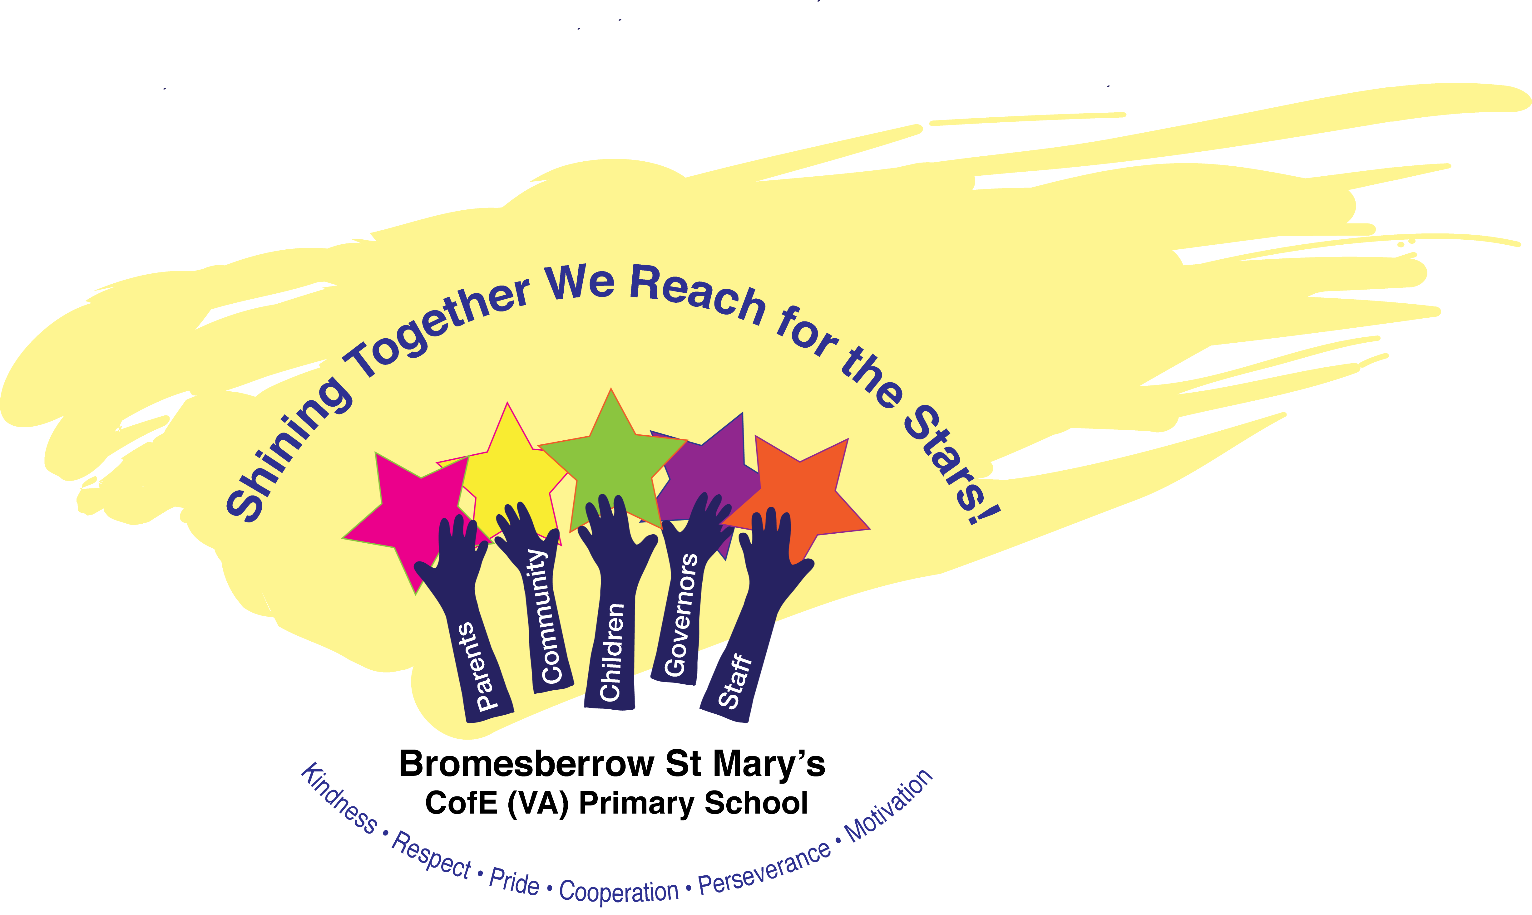

Bromesberrow St Mary’s C of E (VA) Primary School

Collective Worship Policy
March 2024

Contents
Legal Framework .............................................................................................3
School Statement on Collective Worship.....................................................4
Aims and Guiding Principles ...........................................................................5 Organisation......................................................................................................6
Recording, Monitoring and Evaluation...........................................................7
Roles and Responsibilities................................................................................7
Staff Development and Training ....................................................................7
The Right of Withdrawal from Collective Worship.....................................7
Development and Sharing of the Policy ........................................................8

Name of School: Bromesberrow St Mary’s C of E Primary School
School’s Vision: Shining Together, We Reach for the Stars.
All individuals at Bromsberrow St Mary’s are encouraged to flourish and ‘shine’ together; feeling hope for all that lies ahead. As a Church of England school we are inspired by the example of Jesus, described as being ‘The Light of the World’ because of his messages and actions of love and hope. Through nurturing values like this, including kindness, respect and cooperation, our whole school community (children, staff, governors & parents) aim to shine brightly together, to benefit each other and the whole world. We want everyone in our school to feel valued for the unique talents and skills they have and encourage all to be aspirational with the hope to shine brightly and to ‘Reach for the Stars’.

Matthew 5: 14-16
¹⁴ “You are the light of the world. A town built on a hill cannot be hidden.¹⁵ Neither do people light a lamp and put it under a bowl. Instead they put it on its stand, and it gives light to everyone in the house. ¹⁶ In the same way, let your light shine before others, that they may see your good deeds and glorify your Father in heaven."

Legal Framework
There must be a daily act of collective worship in all maintained schools for all pupils, other than those in a nursery class or a nursery school. This can take place at anytime in the school day and in any groupings. Collective worship in a Church of England School must be in accordance with the tenets and practices of the Church of England. In other words the law on collective worship that applies in a community school, “that it should be wholly or mainly of a broadly Christian character”, is not relevant. Worship in Bromesberrow St Mary’s should be distinctly Christian and reflect Anglican traditions.

The Governing Board of school have the responsibility for ensuring that the school can respond to IQ3 in the Statutory Inspection of Anglican and Methodist Schools (SIAMS) Framework 2023, which asks ‘How is collective worship enabling pupils and adults to flourish spiritually?’ They are also tasked with monitoring and evaluating how collective worship is helping pupils and adults flourish spiritually in consultation with the headteacher.

School Statement on Collective Worship
In Bromesberrow St Mary’s worship is central to the life of school and is the main platform for exploring the school’s vision, Shining Together, We Reach for The Stars. Collective worship is a clear expression of our vision, whereby we come together to learn and explore the teachings of Jesus as ‘light of the world’ and how these teachings can be reflected into our day to day lives to enable us to reach for the starts with aspiration. It is well planned and of high quality so that the whole school community is engaged on a journey of discovery, exploring the teachings of Jesus and the Bible. Collective Worship is a time to promote the links we have with the children and is a means by which the children may become concerned with God. It allows our children to express and bear witness to their faith in a school setting. Everything we do is underpinned by this vision and our values which are deeply rooted in Christian theology and supported by biblical text.

For Christians in Church, worship is about honouring God and responding to the loving nature of God as revealed through the Trinity: Father, Son and Holy Spirit. A school is not a Church but is a collection of people who come from a variety of backgrounds for the purpose of education. The family backgrounds may be very different and collective worship must take account of the varied circumstances of staff and pupils.

However, in Bromesberrow St Mary’s the purpose of collective worship will be to lead people to a threshold where they can witness worship and join in, if they wish. It is a place where all can flourish spiritually.

“Worship in (CofE) schools promotes theological and Religious Literacy and liberates participants to an imagining of a different order of justice, mercy and hope”

Through Collective Worship pupils will be offered a space and a place for the telling of the Christian story. They will be offered an understanding of worship through being invited to participate in or observe prayer, reading and reflection on the Bible, liturgy, sacrament and experience of the musical and other imaginative riches of Christianity. Opportunities to reflect on the beauty, joy and pain of the world will be given. Pupils will be given time to consider their responsibilities to others and to grow in love and service. Time will be given for celebration, both for the accomplishments of school members and to mark the seasonal festivals of the Christian (and other faiths⁾ calendar. Pupils will be offered time to be able to contemplate and develop spiritually. Collective Worship in our school is invitational, inspirational and inclusive.

Aims and Guiding Principles
This school follows the guiding principles highlighted in the document: Collective Worship in Church of England Schools Inclusive Invitational Inspiring Guidance Document, May 2021.

Collective worship in Bromesberrow St Mary’s aims to:

- Have a pivotal place in the life of the school.
- Support pupils and adults’ in their spiritual growth
- Be the central vehicle by which the school’s vision is unpacked and explored so that the whole school community is challenged and engaged with the teachings of Jesus and the Bible.
- Provide an experience of worship that will offer opportunities for those present to observe and/or respond to the presence, power and peace of God as understood by Christians. This will always be invitational, offering an opportunity to take part whilst allowing the freedom for those of other faiths and none to be present with integrity.
- Support pupils in the development of their understanding of the Trinitarian nature of God in Christian belief
- Provide a variety of different opportunities for reflection, understanding of diverse liturgical traditions, participation, challenge and enjoyment where all present can be actively involved and develop their own spirituality whilst contributing to the communal journey.
- Help children to become familiar with Christian language and symbolism and the cycle of the Church year so that they are offered a pattern of meanings and a framework into which they can begin to integrate experience.
- Explore a variety of ways of praying, giving children the opportunity to form their own prayers using multi-sensory foci and introduce them to some well know Christian prayers, as well as a variety of prayers of thanksgiving before mealtimes and home time.
- Offer opportunities to all children and staff to develop their skills in planning, leading and evaluating the impact of school worship with the support and shared engagement of the local church community. Pupils will be at the centre of this process taking on increasingly independent roles in planning and leading worship.
- Ensure that materials and themes for worship are carefully selected to make sure pupils understand the work of Christians and the church locally, nationally and globally and how this reflects the teachings of the Bible and the example of Jesus.

Collective Worship is fully inclusive to include the whole school community, church and the local area and is carefully planned so that all involved with worship are able to contribute if they wish. Parents are invited to our Friday Celebration Collective Worship as well as end of term services at church and special occasions e.g. harvest and Christmas. Children and adults are invited to respond to questions in the ways that are important to them. All children attend daily acts of Collective Worship and as Collective Worship is carefully planned children are invited to participate as much as possible in age appropriate ways. When completing the liturgy and prayer to mark the beginning and end of our worship each time children are invited to join in.

Collective worship is an inspirational time for us as a school as it is a time to share our theologically rooted vision through the teachings in the Bible and reflect upon how these teachings could impact our own lives and others. We also ensure worship is a time where we share the stories of inspirational people throughout history and how these people live out our vision and values for example sharing the inspiration story of the Brownlee brothers at the World Triathalon Series and the sacrifice one brother made to help his brother complete the race (Shining Together).

Organisation

Leadership
- Daily worship is planned on a rota system whereby Headteachers and teaching staff take it in turns to deliver Collective Worship. This includes a weekly class worship to have opportunity to reflect and respond in a way that is tailored to class ages. During the course of each term several Collective Worships are led by members of our wider church community and by the children themselves.
- The local incumbent support and lead worship in partnership with leaders on a regular basis, and attend additional services in the church throughout the church’s year where possible and appropriate.
- The local incumbent help and support leaders of collective worship to develop their understanding of Christian theology, the teachings of the Bible and develop a deeper understanding of Anglican traditions and liturgy
- Visitors who may be delivering Collective Worship can refer to the Guidance Materials (Appendix 1)

Planning
- Long Term planning of Collective Worship is carried out by Headteachers and staff adapt the plan where appropriate. The themes chosen alongside our values or Bible Stories, enable staff to deliver inspirational sessions.
- All members of the school community can plan Collective Worship using the resources in school or those readily available online. All staff have a bank of appropriate websites that they can access for resources. Children are actively encouraged to plan Collective Worship and have access to a variety of resources that are age appropriate. Everyone planning and adapting Collective Worship ensures that it is inclusive.
- Collective Worship reflects the Church year by the use of the liturgical colours in the Collective Worship area and by the planning of themes to include major events in the church year. Many of these special times are open to parents and our wider school community.
- Christian values are always discussed in Collective Worship and are written in the Collective Worship area for the children to reflect on.
- During Collective Worship and in RE lessons Bible stories reflecting our school Christian values are examined and discussed.
- The range and variety of materials used, including: websites, artefacts, stories, drama scripts, artwork, music, songs, film clips, focal points e.g. our three candles representing the Trinity.
- During Collective Worship the children are encouraged to reflect on the theme or value and to think how this has any impact on their own spiritual journey.
- Opportunities are provided for children and adults to explore faith in today’s world.
- Explore the Christian belief in the Trinitarian nature of God.
- We have a specifically planned spirituality worship however, spiritual flourishing is seen in all worships through prayer, stillness and reflection.
- We have a pattern for worship which reflects Anglican tradition (starting with the Liturgy and lighting of the candles, following the church calendar).

Organisation

- Collective Worship takes place mainly in the school hall but sometimes in classrooms or our Reflective Garden area when weather permits. Collective Worship services are also held at St Mary’s Church at the end of every school term and for special occasions such as Easter.
- Collective Worship is a whole school occasion.
- Each week there is a Praise Worship time which is given a religious theme by discussing the hymns and songs that are being practiced. We endeavor to introduce the children to hymns and songs that they can become familiar with, and understand the meaning and purpose and that supports the themes and values.
- The liturgical colours of the Christian church year are shown by the colour of the cloth on the Collective Worship table and in the RE areas within each classroom.
- At the start of every Collective Worship our three candles are lit representing the Trinity and act as a focal and reflective area for the children. There are crosses in the hall that the children have made and are used when appropriate in Collective Worship.
- Collective Worship is led initially alongside the Worship team who lead the liturgy for the rest of school to respond to.
- The children are seated in class groups with any adult sitting alongside them.
- Generally Collective Worship is first thing in the morning following registration and lasts 15-20 minutes.
- A prayer is said in each classroom once a day, the teacher decides when this is most fitting for their class.
- All teaching staff lead Collective Worship over the course of a week and all staff including support staff are invited to attend Collective Worship.

Recording, Monitoring and Evaluation
It is important that any recording is limited to only useful documents. A rota for each half term is drawn and shared with staff for each week. The detail of the value, story/topic, hymn, and prayer used in each Collective Worship will be recorded within our Collective Worship book. The Head and a member of the church community will communicate at least once a term and discuss how the plan will be followed and the dates for worship at church. Relevant information will then be passed on to staff involved.

Children may be withdrawn for extra curriculum support during Collective Worship time so as to make efficient use of limited Teaching Partner time. Children will be withdrawn for a maximum of once a week and teachers will monitor this to ensure children do not regularly miss Collective Worship on the same days.

Worship will be monitored as part of the cycle covered by the School Development Plan and by the Governing Board. Worship will be observed, children will be questioned about their experience and staff will be asked to comment on aspects such as resources. Worship will be observed as part of our normal monitoring with Headteachers and Governors. Children’s contributions to the self- evaluation processes are very important and for part of the SEF and SDP.

Roles and Responsibilities
The Governing Body
The Co Headteachers
Teaching and support staff
Pupils
Parents and carers
Visitors

Staff Development and Training
We ensure that all staff, including support staff, receive appropriate training and opportunities for professional development, both as individuals and as groups or teams. Additionally, support and guidance are provided for visitors and the clergy who lead collective worship.

The Right of Withdrawal from Collective Worship
The 1944 and1988 Education Acts state that parents have the right to withdraw children from collective worship and suitable arrangements should be made to accommodate these children.

In Bromesberrow St Mary’s C of E Primary School there are many children whose familiar are members of another faith, or who hold a non-religious world view. When introducing new parents to the school it is shared how collective worships is a central place in the life of our church school and that Christian tradition is followed.

On occasions, a parent may make a request for their child to be withdrawn from Collective Worship. There is an expectation that parents wishing to request a withdrawal will meet with the headteacher to discuss their concerns and requirements. It may be helpful to establish:

- The elements of worship in which the parent would object to the child taking part
- The practical implications of withdrawal
- Whether the parent will require any advanced notice of such worship, and if so, how much

Where parents have withdrawn their children from collective worship and request religious worship according to their particular faith or denomination, the governors and head teacher will seek to respond positively to such requests providing:

- Such arrangements can be made at no additional cost to the school
- That the alternative provision would be consistent with the overall purposes of the school curriculum as set out in the Education Acts

If the Parent asks that a pupil should be wholly or partly excused from attending any religious worship at the school, then the school must comply.
(This means that a parent may, for example, request their child does not take part in a carol service when otherwise the child takes part in daily collective worship.)

Development and Sharing of the Policy
We ensure that this policy is known to all staff and governors, parents and carers and, as appropriate, to all pupils. This policy is available on our school website.

This policy is to be read in conjunction with the Collective Worship in Church of England Schools Inclusive Invitational Inspiring Guidance Document and the Diocesan Collective Worship Guidance Document.

We ensure that the principles for collective worship are reflected and applied in our policies and practice including those that are concerned with:
- Pupils’ personal development and wellbeing
- SMSC and PSHE
- Staff recruitment, retention and professional development
- Care, guidance and support
- Behaviour, discipline and exclusions
- Working in partnership with parents, carers and guardians
- Working with the wider community
- We also ensure that information about collective worship is included in the school prospectus and on the school website.

Approval/review by governing body
Headteacher signed: Date:
Chair of Governors signed: Date:
Date of next review: Date:

Link to:
RE Policy
Behaviour Policy

CEEO Vision statement “Deeply Christian, Serving the Common Good” Autumn 2016
Collective Worship in a CofE school must be in alignment with the religious foundation of the school (Christian), however there is a responsibility for schools in all contexts to mark, respond and learn from the festivals of other faiths. This may be designated as a separate act, not to be conflated with collective worship.
“To worship is to quicken the conscience by the holiness of God, to feed the mind with the truth of God, to purge the imagination by the beauty of God, to open the heart to the love of God and to devote the will to the purpose of God”. William Temple (1881-1894)

