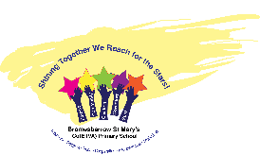
What a Science Lesson looks like at Bromesberrow
- Children being scientists in line with our enquiry led curriculum- learning new substantive (facts) and disciplinary (doing science) knowledge.

- Activating prior knowledge through questioning, activation stations and knowledge organisers.

- A clear purpose for learning- children know what they will be learning about including vocabulary (captured on front covers and knowledge organisers).

- A culture of questioning, adults and children.

- Adaptive practice (stretching and pulling) through:

* Effective modelling ‘I do, We do, You do’.
* Providing scaffolds where needed (Clicker, Widget)
* New material taught in small steps,
* Modelling thinking and careful questioning.

- Assessment of/for learning (use Big Books to capture a cold and hot task and ongoing assessment for learning to address misconceptions in the moment)
